QSAR Bioactivity Prediction:
Regression and Classification Study Using Morgan
Fingerprints and SHAP-Based Feature Attribution

A PROJECT REPORT

Submitted by:
Shivananda Reddy Kasula
(Register Number: 39958)

to
Institute of Bioinformatics and Applied Biotechnology & Biocon Academy

in partial fulfilment of the requirements for
Syngene IBAB Certification Program in Artificial Intelligence in Life Sciences
(Certificate to be jointly awarded by the Biocon Academy and IBAB, Bengaluru)

under the guidance of:
Shyam Rajagopalan
Prof. Srivastan

August 2026


DECLARATION

I certify that

a) the work contained in this report is original and has been done by me under the guidance of my supervisor(s).
b) I have followed the guidelines provided by the Department in preparing the report.
c) I have conformed to the norms and guidelines given in the Honor Code of Conduct of the Institute.
d) whenever I have used materials (data, theoretical analysis, figures, and text) from other sources, I have given due credit to them by citing them in the text of the report and giving their details in the references. Further, I have taken permission from the copyright owners of the sources, whenever necessary.

Signed by:

Shivananda Reddy Kasula
Register Number: 39958

Date:
Place: Bengaluru

CERTIFICATE

It is certified that the work contained in this report titled "Interpretable Machine Learning for QSAR Bioactivity Prediction: A Comparative Regression and Classification Study Using Morgan Fingerprints and SHAP-Based Feature Attribution" is the original work done by Shivananda Reddy Kasula (Register Number 39958) and has been carried out under my supervision.

Signed by:

Shyam Rajagopalan

Date:

ACKNOWLEDGEMENT

I would like to express my sincere gratitude to my faculty mentor, Shyam Rajagopalan, for continuous guidance, critical feedback and encouragement throughout the course of this project. I am thankful to the Institute of Bioinformatics and Applied Biotechnology (IBAB) and Biocon Academy for providing the infrastructure, computational resources and academic environment that made this work possible. I also thank the faculty and staff of the Syngene IBAB Certification Program in Artificial Intelligence in Life Sciences for their instruction and support, and my fellow participants for many useful discussions.

Finally, I thank my family for their patience and support during the course of this work.

Shivananda Reddy Kasula

ABSTRACT

Quantitative structure–activity relationship (QSAR) modelling seeks to relate the chemical structure of a molecule to its measured biological activity, and has become a routine component of early-stage drug discovery as a means of prioritising compounds before synthesis and assay. The increasing volume of curated bioactivity data in public repositories such as ChEMBL has made it feasible to train machine learning models on thousands of structure–activity pairs, but two practical difficulties persist: the choice of molecular representation and feature selection strategy strongly influences predictive performance, and the resulting ensemble models are difficult to interpret in chemical terms.
This project addresses both problems through a systematic comparative study on a curated bioactivity dataset supplied in blinded form by the industrial partner, comprising 2,700 records and approximately 2,350 unique compounds after removal of duplicate structures. The identity of the biological target was not disclosed, so the analysis is necessarily methodological rather than target-specific. Molecules were encoded as circular Morgan fingerprints (radius 2) at 1024- and 2048-bit resolutions, optionally augmented with calculated physicochemical descriptors. Two complementary modelling tasks were pursued. In the regression task, the continuous pChEMBL value was predicted using seven algorithms spanning linear models (Linear Regression, Ridge, Lasso) and ensemble methods (Random Forest, Gradient Boosting, Bagging, XGBoost). In the classification task, compounds were labelled active or inactive at a threshold of pChEMBL ≥ 5 and six classifiers were evaluated. Nine distinct feature-selection configurations were compared, including variance thresholding, principal component analysis and SHAP-guided selection of the top 50 to 350 features. Model interpretability was addressed using SHAP (SHapley Additive exPlanations) values computed for the tree-based regressors.
Under ten-fold cross-validation the Random Forest regressor gave the best generalisation performance (R² = 0.664 ± 0.051; RMSE = 0.655 log units), closely followed by XGBoost (R² = 0.653) and Bagging (R² = 0.634), while Lasso failed entirely (R² = −0.006), collapsing to the mean predictor. Grid-search hyperparameter optimisation did not improve cross-validated performance beyond the default configurations, the best tuned model reaching R² = 0.671 against 0.664 untuned, indicating that the performance ceiling is set by the molecular representation rather than by model configuration. SHAP-guided feature reduction degraded performance monotonically below 300 features, showing that predictive signal in this dataset is distributed across many weakly informative fingerprint bits rather than concentrated in a compact subset.
The classification results require careful interpretation. Although all six classifiers achieved apparent test accuracies between 0.955 and 0.969, the dataset is severely imbalanced, with active compounds constituting approximately 96.5% of the data. A trivial classifier predicting the majority class for every molecule would achieve 0.965 accuracy, which exceeds or matches five of the six trained models. Reconstruction of the confusion matrices confirmed that the best-accuracy model, Random Forest, correctly identified only 7 of 25 inactive compounds (specificity 0.28). Ranking-based metrics were more informative: ROC-AUC values of 0.81 to 0.95 demonstrate that the models do carry genuine discriminative signal even where thresholded accuracy is uninformative. This finding is reported explicitly rather than obscured, and forms the principal methodological conclusion of the study.
The work demonstrates that ensemble learning on circular fingerprints can predict pChEMBL values to within approximately 0.65 log units, that interpretability analysis via SHAP identifies a small set of consistently influential structural features shared across independently trained models, and that evaluation metric selection is decisive when working with the imbalanced activity distributions typical of curated bioactivity repositories.

Keywords: QSAR; bioactivity prediction; Morgan fingerprints; Random Forest; XGBoost; SHAP; feature selection; class imbalance; ChEMBL; cheminformatics.

TABLE OF CONTENTS

Page
Declaration ii
Certificate iii
Acknowledgement iv
Abstract v
Table of Contents vii
List of Tables ix
List of Figures x
List of Abbreviations xi

Chapter 1: Introduction 1
1.1 Drug discovery and the attrition problem 1
1.2 Quantitative structure–activity relationships 1
1.3 Machine learning approaches to QSAR 2
1.4 Molecular representation and the role of fingerprints 3
1.5 The interpretability problem 4
1.6 Statement of the problem 4
1.7 Objectives 5

Chapter 2: Literature Survey 7
2.1 Historical development of QSAR 7
2.2 Molecular descriptors and structural fingerprints 8
2.3 Machine learning algorithms applied to QSAR 9
2.4 Regression versus classification formulations 10
2.5 Feature selection and dimensionality reduction 10
2.6 Model interpretability and SHAP 11
2.7 Validation practice and class imbalance 12
2.8 Gaps identified in the literature 13

Chapter 3: Materials and Methods 14
3.1 Computational environment and software 14
3.2 Dataset and data source 14
3.3 Exploratory data analysis and preprocessing 15
3.4 Molecular representation 16
3.5 Definition of the two modelling tasks 17
3.6 Feature selection strategies 18
3.7 Learning algorithms 19
3.8 Model validation strategy 20
3.9 Hyperparameter optimisation 21
3.10 Performance metrics 21
3.11 Interpretability analysis using SHAP 23

Chapter 4: Results and Discussion 25
4.1 Dataset composition and activity distribution 25
4.2 Baseline regression performance 26
4.3 Effect of representation and feature selection 28
4.4 Hyperparameter optimisation 31
4.5 SHAP analysis of the regression models 33
4.5.1 Structural motifs associated with potency 36
4.6 Binary classification performance 38
4.7 Cross-validated classification performance 39
4.8 Class imbalance and the majority-class baseline 41
4.9 SHAP analysis of the classification model 44
4.10 Comparison of the regression and classification tasks 46
4.11 Limitations of the study 47

Chapter 5: Summary and Conclusions 49
5.1 Summary 49
5.2 Concluding remarks 50
5.3 Future work 51

Data and Code Availability 53

References 54
Appendix A: Complete experimental result tables 57
Appendix B: Software configuration and reproducibility notes 59

LIST OF TABLES

Table Title Page
3.1 Software libraries and versions used 12
3.2 Summary of the nine feature-selection configurations 16
3.3 Learning algorithms evaluated in each task 17
4.1 Composition of the curated dataset 21
4.2 Ten-fold cross-validated regression performance 22
4.3 Regression performance across feature-selection strategies 24
4.4 Performance after grid-search hyperparameter optimisation 27
4.5 Twenty most influential features by mean absolute SHAP value 28
4.6 Hold-out classification performance 31
4.7 Ten-fold cross-validated classification performance 33
4.8 Comparison against the majority-class baseline 34
4.9 Reconstructed confusion matrices for all classifiers 35
A.1 Full regression sweep, all models and configurations 49

LIST OF FIGURES

Figure Title Page
3.1 Overall computational workflow 15
4.1 Cross-validated R² for the seven regression algorithms 22
4.2 Cross-validated RMSE for the seven regression algorithms 23
4.3 Random Forest R² across nine feature-selection strategies 24
4.4 Cross-validated R² before and after grid-search optimisation 26
4.5 Twenty most influential features, Random Forest 29
4.6 Twenty most influential features, Gradient Boosting 29
4.7 Structural motifs associated with potency 29
4.8 Classification accuracy against the majority-class baseline 32
4.9 Sensitivity and specificity for all six classifiers 35
4.10 Confusion matrices for Random Forest and Logistic Regression 36
4.11 ROC-AUC under hold-out and cross-validated evaluation 37
4.12 SHAP beeswarm summary for the Random Forest classifier 37

LIST OF ABBREVIATIONS

Abbreviation | Description
AUC | Area Under the Curve
ChEMBL | Chemical database of bioactive molecules maintained by EMBL-EBI
CV | Cross-Validation
ECFP | Extended-Connectivity Fingerprint
FN | False Negative
FP | False Positive
GBM | Gradient Boosting Machine
IC₅₀ | Half-maximal Inhibitory Concentration
LightGBM | Light Gradient Boosting Machine
MAE | Mean Absolute Error
ML | Machine Learning
MSE | Mean Squared Error
PCA | Principal Component Analysis
pChEMBL | Negative logarithm of a half-maximal activity concentration
QSAR | Quantitative Structure–Activity Relationship
RDKit | Open-source cheminformatics toolkit
RF | Random Forest
RMSE | Root Mean Squared Error
ROC | Receiver Operating Characteristic
SD | Standard Deviation
SHAP | SHapley Additive exPlanations
SMILES | Simplified Molecular Input Line Entry System
SVM | Support Vector Machine
TN | True Negative
TP | True Positive
XGBoost | Extreme Gradient Boosting

Chapter 1

Introduction

1.1 Drug discovery and the attrition problem
The development of a new therapeutic agent is among the most expensive and failure-prone undertakings in applied science. A candidate molecule must satisfy simultaneous and often conflicting requirements: it must bind its intended biological target with sufficient affinity, reach that target at an adequate concentration, avoid unintended interactions, and remain chemically and metabolically stable long enough to exert an effect. The majority of compounds that enter a discovery programme fail to meet these criteria, and the cost of each failure rises sharply the later it is discovered. Reducing attrition therefore depends less on testing more compounds than on testing better-chosen compounds.
The chemical space accessible to medicinal chemistry is far larger than any experimental programme can sample. Estimates of the number of synthetically tractable drug-like molecules exceed 10⁶⁰, against which even the largest industrial compound collections, numbering a few million, represent a vanishingly small fraction. Exhaustive experimental screening is therefore not merely impractical but conceptually impossible. Any strategy for navigating chemical space must be selective, and selectivity requires some model, whether implicit in the intuition of an experienced chemist or explicit in a computational framework, that predicts activity from structure before synthesis is attempted.
Computational prioritisation of compounds addresses this directly. If a model can rank an untested library such that active compounds appear preferentially near the top, the experimental effort required to find a hit falls in proportion to the enrichment achieved. The value of such a model does not depend on perfect prediction; it depends on ranking well enough to make the subsequent experiment more efficient than random selection. This framing, prediction as prioritisation rather than as substitution for measurement, underlies the work described in this report.

1.2 Quantitative structure–activity relationships
The premise that biological activity is a function of chemical structure is the foundation of medicinal chemistry. Quantitative structure–activity relationship (QSAR) modelling makes this premise explicit and testable by constructing a mathematical mapping from numerical representations of molecular structure to measured biological endpoints. In its general form a QSAR model may be written as
y = f (x₁, x₂, …, xₙ) + ε (1.1)
where y is the measured activity, x₁ to xₙ are numerical descriptors computed from molecular structure, f is a functional form learned from data, and ε represents experimental and model error. The scientific content of a QSAR study lies in three choices: which descriptors to compute, which functional form to permit, and how to establish that the fitted relationship generalises beyond the compounds used to construct it.
Classical QSAR, originating in the work of Hansch and Fujita in the 1960s, employed a small number of physically interpretable descriptors, typically hydrophobicity, electronic and steric parameters, combined in a linear regression over a congeneric series of closely related analogues. This approach produced models that were interpretable in mechanistic terms, but their applicability was narrow: a model fitted to one chemical series rarely transferred to another. The constraint was not a defect of the method but a consequence of the small datasets and limited descriptor sets then available.
Contemporary QSAR operates in a different regime. Public repositories such as ChEMBL aggregate millions of curated structure–activity measurements across thousands of targets, and cheminformatics toolkits can compute thousands of descriptors for a molecule in milliseconds. The modelling problem shifts accordingly, from extracting a relationship out of scarce data to selecting a generalisable relationship out of an over-parameterised feature space. This shift motivates the use of machine learning methods capable of handling high-dimensional, sparse and correlated inputs.

1.3 Machine learning approaches to QSAR
Machine learning algorithms relax the requirement that the functional form of the structure–activity relationship be specified in advance. Rather than assuming linearity, they infer the form of the mapping from the data, which allows them to capture the non-additive and threshold-like behaviour characteristic of molecular recognition. Two families dominate current practice.
Ensemble tree methods, including Random Forest, Gradient Boosting and their optimised implementations such as XGBoost and LightGBM, construct many decision trees and aggregate their predictions. They handle sparse binary inputs natively, require little preprocessing, are robust to irrelevant features, and capture interactions between features without these being specified. These properties make them well suited to fingerprint representations, and they remain competitive baselines against far more elaborate architectures.
Deep learning approaches, particularly graph neural networks that operate directly on the molecular graph, learn the representation and the predictor jointly rather than accepting a fixed descriptor set. On very large datasets these methods can exceed the performance of fingerprint-based models. On datasets of the size considered here, comprising a few thousand compounds, the evidence for their superiority is considerably weaker, and the additional computational and interpretive cost is substantial. This project therefore concentrates on ensemble methods applied to fixed fingerprint representations, a choice made for reasons of sample size and interpretability rather than convenience.

1.4 Molecular representation and the role of fingerprints
No machine learning algorithm operates on a molecule directly; it operates on a numerical vector derived from the molecule. The mapping from structure to vector, the molecular representation, therefore determines the ceiling of achievable performance. Information discarded at this stage cannot be recovered by any subsequent algorithm.
Circular fingerprints, of which the Morgan fingerprint and the closely related extended-connectivity fingerprint (ECFP) family are the most widely used, encode the local environment of every atom in a molecule up to a specified bond radius. Each distinct environment is hashed to a position in a fixed-length bit vector, which is set to one if that substructure is present. The result is a sparse binary vector whose components correspond to the presence or absence of specific structural motifs.
Two design parameters govern this representation. The radius determines the size of the substructures encoded: a radius of two captures fragments extending two bonds from each atom, corresponding approximately to a functional group and its immediate surroundings. The bit-vector length determines the resolution: shorter vectors are more compact but incur bit collisions, in which chemically distinct substructures are hashed to the same position, while longer vectors reduce collisions at the cost of increased sparsity and dimensionality. This project evaluates both 1024-bit and 2048-bit representations at radius two, and additionally examines whether augmenting fingerprints with calculated physicochemical descriptors improves prediction.

1.5 The interpretability problem
An ensemble of several hundred decision trees is not amenable to direct inspection. This creates a practical difficulty in a discovery setting, where the value of a model lies not only in its predictions but in the guidance it provides for compound design. A medicinal chemist presented with a predicted potency and no accompanying rationale has limited basis for acting upon it, and no basis at all for judging whether the prediction rests on chemically sensible grounds or on an artefact of the training data.
SHAP (SHapley Additive exPlanations) provides a principled response to this difficulty. Drawing on the Shapley value from cooperative game theory, it assigns to each feature of each individual prediction a contribution representing that feature’s marginal effect on the model output, averaged over all possible orderings in which features might be introduced. The resulting attributions are additive, summing to the difference between the prediction and the model’s expected output, and are consistent in the sense that a feature whose contribution increases in a modified model cannot receive a lower attribution. For tree ensembles an exact polynomial-time algorithm is available, making the analysis tractable at the scale considered here.
SHAP attributions serve two purposes in this work. Aggregated across compounds they identify which structural features the model relies upon globally, providing a basis for chemical interpretation. Used as a feature-importance criterion they also provide a principled means of ranking features for selection, and this project evaluates whether reducing the representation to the highest-attribution features preserves predictive performance.

1.6 Statement of the problem
Published QSAR studies frequently report a single model configuration, evaluated on a single random partition of the data, using a single performance metric. Such reports leave three questions unresolved. It is unclear how much of the reported performance is attributable to the choice of representation as opposed to the choice of algorithm; whether the performance would survive a different random partition of the data; and whether the headline metric is appropriate to the distribution of the endpoint being predicted. The third question is particularly consequential when the endpoint is binary and the classes are unbalanced, a situation that arises routinely in curated bioactivity data because compounds are typically submitted for assay after a prior expectation of activity has been formed.
This project addresses these questions by conducting a systematic comparison rather than reporting a single model. The same curated dataset is modelled under both a regression formulation, predicting the continuous pChEMBL value, and a classification formulation, predicting activity against a fixed potency threshold. Multiple algorithms are evaluated under each formulation, multiple feature-selection strategies are compared, both hold-out and cross-validated estimates are reported, and model behaviour is examined through SHAP attribution. Particular attention is given to whether the reported metrics support the conclusions that would conventionally be drawn from them.

1.7 Objectives
The specific objectives of this project were:
- To curate a bioactivity dataset by removing duplicate structures and to characterise the distribution of the activity endpoint.
- To generate Morgan fingerprint representations at radius two in 1024-bit and 2048-bit resolutions, and to evaluate the effect of augmenting these with calculated physicochemical descriptors.
- To construct and comparatively evaluate seven regression algorithms for the prediction of continuous pChEMBL values, using both hold-out and ten-fold cross-validated estimates of generalisation performance.
- To construct and comparatively evaluate six classification algorithms for the prediction of binary activity at a threshold of pChEMBL ≥ 5, using both hold-out and stratified ten-fold cross-validated estimates.
- To compare nine feature-selection and dimensionality-reduction configurations, including variance thresholding, principal component analysis, Lasso-based selection and SHAP-guided selection at several retention levels.
- To optimise the hyperparameters of the leading regression models by exhaustive grid search and to quantify the resulting change in generalisation performance.
- To compute SHAP attributions for the tree-based models, to identify the structural features on which the models principally depend, and to assess the consistency of these attributions across independently trained algorithms.
- To critically evaluate the adequacy of the reported performance metrics in light of the observed class distribution, and to establish appropriate baselines against which model performance should be judged.

Chapter 2

Literature Survey

2.1 Historical development of QSAR
The systematic correlation of chemical structure with biological effect predates modern computation. Nineteenth-century observations that narcotic potency tracked with oil–water partitioning established that a bulk physicochemical property could govern a biological response, an insight that survives in the continued importance of lipophilicity in contemporary drug design.
The formalisation of QSAR as a quantitative discipline is generally attributed to Hansch and Fujita, whose 1964 formulation expressed biological activity as a linear combination of hydrophobic, electronic and steric substituent constants. The Hansch approach imposed strong assumptions: activity was linear or parabolic in each descriptor, effects were additive, and the compounds analysed belonged to a single congeneric series differing only in substitution pattern. Within these constraints the method was powerful and, importantly, mechanistically interpretable, since each coefficient carried a physical meaning.
Successive generations of QSAR relaxed these constraints. Three-dimensional methods introduced in the late 1980s aligned molecules in space and correlated activity with interaction fields sampled on a surrounding grid, capturing shape and electrostatic complementarity that two-dimensional descriptors miss, at the cost of requiring a reliable alignment hypothesis. The subsequent expansion of descriptor libraries to thousands of computable quantities, and the parallel growth of publicly available bioactivity data, shifted the field towards statistical learning methods able to operate without a specified functional form.
Cherkasov and colleagues, reviewing the field in 2014, characterised this trajectory as a movement from small, interpretable, narrowly applicable models towards large, opaque, broadly applicable ones, and identified the recovery of interpretability as a central outstanding challenge. That characterisation frames the present work, which pairs high-capacity ensemble models with post hoc attribution analysis in an attempt to obtain both properties simultaneously.

2.2 Molecular descriptors and structural fingerprints
Molecular descriptors fall into several broad classes. Constitutional descriptors count atoms, bonds and rings. Topological descriptors summarise the connectivity graph through indices such as the Wiener and Randić indices. Physicochemical descriptors estimate properties including the octanol–water partition coefficient, topological polar surface area and hydrogen-bond donor and acceptor counts, several of which appear in the widely applied rule-of-five heuristics for oral bioavailability. Comprehensive descriptor calculators such as Mordred compute on the order of one to two thousand such quantities.
Structural fingerprints occupy a distinct position. Rather than summarising a molecule through global properties, they enumerate the substructures it contains. Path-based fingerprints encode linear atom sequences; substructure-key fingerprints record the presence of a predefined dictionary of fragments; circular fingerprints encode atom-centred neighbourhoods of increasing radius.
The Morgan fingerprint, described in its modern form by Rogers and Hahn in 2010 under the name extended-connectivity fingerprint, has become the default representation for machine-learned QSAR. Its construction begins by assigning each atom an initial identifier derived from its element, degree, charge and hydrogen count. These identifiers are then iteratively updated by hashing each atom’s identifier together with those of its bonded neighbours, so that after r iterations each identifier encodes the atom’s environment out to radius r. The full set of identifiers generated across all iterations is folded into a fixed-length bit vector.
Two consequences of this construction bear on the present work. First, folding introduces bit collisions: distinct substructures may set the same bit, and the frequency of collision rises as the vector is shortened. Second, individual bits are not intrinsically interpretable, since a bit index carries no chemical meaning independent of the hashing function used to produce it. Recovering the substructure associated with a given bit requires retaining the bit-information mapping generated during fingerprint construction, a step whose omission limits the chemical interpretation possible in any subsequent attribution analysis.
Comparative evaluations have repeatedly found circular fingerprints to be strong general-purpose representations. Benchmark studies including MoleculeNet report that fingerprint-based ensemble models remain competitive with learned graph representations on datasets below roughly ten thousand compounds, with the advantage shifting towards learned representations only at larger scale.

2.3 Machine learning algorithms applied to QSAR
Linear regression and its regularised variants provide the baseline against which non-linear methods must be judged. Ridge regression, introduced by Hoerl and Kennard, penalises the sum of squared coefficients, shrinking them towards zero and stabilising estimation when predictors are collinear. The Lasso, introduced by Tibshirani, penalises the sum of absolute coefficients and drives some to exactly zero, performing selection and estimation simultaneously. On sparse binary fingerprint data both encounter difficulty: individual bits are weak and highly correlated predictors, and an aggressive L1 penalty can eliminate the entire feature set, a failure mode observed in the present study.
Random Forest, introduced by Breiman in 2001, constructs an ensemble of decision trees, each fitted to a bootstrap resample of the training data and each considering a random subset of features at every split. Averaging over trees reduces variance without a corresponding increase in bias, and the randomisation decorrelates the individual learners. The method requires little tuning, tolerates irrelevant features, and has become a standard QSAR baseline.
Gradient boosting, formalised by Friedman in 2001, builds an ensemble sequentially, with each successive learner fitted to the residuals of the current ensemble. Boosted ensembles typically achieve lower bias than bagged ensembles but are more sensitive to hyperparameter choice and depend more heavily on adequate regularisation. XGBoost, described by Chen and Guestrin, and LightGBM, described by Ke and colleagues, provide efficient implementations incorporating explicit regularisation terms, subsampling of rows and columns, and algorithmic optimisations that make large ensembles computationally tractable.
Bagging, in its general form, applies bootstrap aggregation to any base estimator and provides a variance-reduction mechanism independent of the specific learner. Its inclusion in a comparative study serves as a control, distinguishing gains attributable to ensemble averaging in general from gains attributable to the particular tree-construction strategies of Random Forest or boosting.

2.4 Regression versus classification formulations
A bioactivity endpoint measured as a concentration is intrinsically continuous, and is conventionally transformed to a logarithmic scale, the pChEMBL value, to compress its range and to give the errors a more nearly normal distribution. Modelling this quantity directly, as a regression problem, preserves all the information in the measurement.
Nevertheless, classification formulations remain common. The endpoint is dichotomised at a potency threshold and the model predicts class membership. This is defended on three grounds: the decision the model informs is often itself binary, in that a compound is either advanced or not; assay measurements near the limits of the dynamic range may be unreliable as continuous quantities while remaining informative as class labels; and heterogeneous data aggregated across assays may be comparable in rank but not in absolute value.
The cost of dichotomisation is a loss of information: compounds differing by three orders of magnitude in potency receive identical labels if both lie above the threshold, and a pair of compounds separated by a negligible experimental difference may receive opposite labels if they straddle it. A further consequence, central to the findings of this study, is that the class distribution produced by thresholding is determined jointly by the threshold and by the composition of the dataset, and may be severely unbalanced. Curated repositories are enriched in active compounds because compounds are typically assayed after a prior expectation of activity has been formed, and because negative results are published less consistently than positive ones.

2.5 Feature selection and dimensionality reduction
A 1024-bit fingerprint over a few thousand compounds yields a matrix in which features outnumber observations by a factor approaching one half, and in which most columns are sparse. Reducing dimensionality may improve generalisation by removing noise, reduce computational cost, and simplify interpretation, but may equally discard signal.
Filter methods evaluate features independently of the model. Variance thresholding removes features whose values are near-constant, a natural first step for fingerprints, where many bits are set in very few molecules. Correlation filters remove redundant features. Filter methods are computationally cheap but ignore feature interactions.
Embedded methods perform selection during model fitting. Lasso regularisation is the canonical example; tree-based impurity importances provide another, although these are known to be biased towards high-cardinality features and unstable under correlation among predictors.
Principal component analysis constructs orthogonal linear combinations of the original features ordered by variance explained. It is effective at compression but destroys interpretability, since each component mixes many fingerprint bits, and it is variance-driven rather than target-driven: a direction of high variance need not be predictive.
SHAP-based selection has been proposed as an alternative that inherits the theoretical guarantees of Shapley attribution. Features are ranked by mean absolute attribution across a reference set and the highest-ranked retained. Reported evaluations are mixed, and the outcome appears to depend on whether the predictive signal is concentrated in a small subset of features or distributed across many weak ones. The present study contributes evidence on this question at several retention levels.

2.6 Model interpretability and SHAP
Interpretability methods for machine learning models divide into those that constrain the model to be intrinsically interpretable and those that explain an unconstrained model after fitting. The latter category has expanded rapidly, and includes local surrogate methods that fit a simple model in the neighbourhood of a prediction, and attribution methods that distribute the prediction among the input features.
Lundberg and Lee showed in 2017 that several previously proposed attribution methods are special cases of a single class of additive feature-attribution models, and that within this class the Shapley values are the unique solution satisfying local accuracy, missingness and consistency. Local accuracy requires that attributions sum to the difference between the prediction and a baseline expectation; missingness requires that a feature absent from the input receives zero attribution; consistency requires that if a model is changed so that a feature’s marginal contribution increases, its attribution does not decrease.
The general computation of Shapley values requires evaluation over all feature subsets and is exponential in the number of features. Lundberg and colleagues subsequently described TreeSHAP, an algorithm exploiting the structure of decision trees to compute exact attributions in polynomial time, which made the approach practical for the tree ensembles that dominate tabular and fingerprint-based modelling.
Applications in cheminformatics have used SHAP to rationalise activity predictions in terms of substructural contributions, to detect reliance on artefactual features, and to compare the internal logic of models that achieve similar aggregate accuracy. Jiménez-Luna and colleagues, reviewing explainable artificial intelligence in drug discovery, note that attribution methods identify statistical dependence within the model rather than causal structure in the underlying chemistry, and caution that a feature receiving high attribution should be treated as a hypothesis for experimental follow-up rather than as an established determinant of activity.

2.7 Validation practice and class imbalance
Golbraikh and Tropsha argued influentially that internal cross-validation statistics alone do not establish predictive ability, and that external validation on compounds withheld entirely from model development is necessary. Tropsha subsequently codified best practice for QSAR model development, emphasising rigorous data curation, external validation, applicability-domain definition and the reporting of appropriate statistics.
Random partitioning of compounds between training and test sets, the approach adopted in the present study, is known to yield optimistic estimates when the dataset contains structurally similar analogue series, since near-identical compounds may be divided across the partition. Scaffold-based and time-based splitting protocols provide more demanding assessments, and Sheridan has argued that time-split validation most closely reproduces the prospective setting in which a model is actually deployed.
Class imbalance introduces a distinct evaluation hazard. When one class predominates, accuracy is dominated by performance on that class, and a classifier assigning every instance to the majority achieves an accuracy equal to the majority proportion. Reporting accuracy without reference to this baseline can therefore present an uninformative model as a highly successful one. Threshold-independent measures such as the area under the receiver operating characteristic curve are less affected, since they assess the ranking induced by predicted scores rather than the labels produced at a fixed cut-off; but Saito and Rehmsmeier have shown that even ROC-AUC can appear favourable under strong imbalance, and recommend precision–recall analysis as a more sensitive alternative when the minority class is the class of interest. Class-specific measures, sensitivity and specificity reported separately, provide the most direct diagnosis of the failure mode.
Remedies for imbalance include resampling of the training data, either by oversampling the minority class, as in the SMOTE algorithm of Chawla and colleagues, or by undersampling the majority; assignment of asymmetric misclassification costs; and adjustment of the decision threshold applied to predicted probabilities. None of these was applied in the present study, and the consequences of this omission are examined explicitly in Chapter 4.

2.8 Gaps identified in the literature
Four gaps emerge from the foregoing survey and inform the design of this project.
First, comparative studies that vary representation and feature selection systematically while holding the dataset and evaluation protocol fixed remain less common than studies reporting a single optimised configuration. Without such comparisons, the relative contribution of representation and algorithm cannot be separated.
Second, evidence on SHAP-guided feature selection is limited and inconsistent, and the conditions under which it preserves performance are not well characterised.
Third, the practical consequences of class imbalance in curated bioactivity data are widely acknowledged in principle but inconsistently addressed in reporting practice, with accuracy frequently quoted in the absence of a majority-class baseline.
Fourth, interpretability analyses are commonly presented for a single model, leaving open whether the features identified reflect stable structure–activity relationships or the idiosyncrasies of one fitted ensemble. Comparing attributions across independently trained algorithms provides a straightforward test of stability that is seldom reported.

Chapter 3

Materials and Methods

3.1 Computational environment and software
All modelling was carried out in Python 3 on a Linux workstation. Molecular structure handling and fingerprint generation used the RDKit cheminformatics toolkit. Machine learning algorithms, cross-validation utilities, feature-selection transformers and evaluation metrics were taken from scikit-learn, with the exception of the gradient-boosting implementations XGBoost and LightGBM, which were used through their own libraries. Interpretability analysis used the SHAP package. Numerical work used NumPy, tabular data handling used pandas, and figures were produced with Matplotlib. The libraries employed are listed in Table 3.1.
Table 3.1. Software libraries used in this project. Version numbers should be recorded from the working environment before final submission.
Library | Purpose
Python 3 | Programming language and runtime
RDKit | SMILES parsing, molecular object handling, Morgan fingerprint generation
scikit-learn | Linear and ensemble models, cross-validation, feature selection, metrics
XGBoost | Extreme gradient boosting regressor and classifier
LightGBM | Gradient boosting classifier used in the classification task
SHAP | Shapley additive explanation values for tree ensembles
pandas | Tabular data manipulation and result export
NumPy | Numerical array operations
Matplotlib | Figure generation

3.2 Dataset and data source
The dataset consisted of curated bioactivity measurements supplied as a comma-separated file containing, for each record, a ChEMBL molecule identifier, a SMILES string encoding the chemical structure, and a pChEMBL value representing the measured activity on a negative logarithmic scale. The pChEMBL value is defined by ChEMBL as the negative base-ten logarithm of a molar half-maximal activity concentration, so that a compound with an IC50 of 1 µM has a pChEMBL value of 6.0 and higher values denote greater potency. As supplied, the file contained 2,700 records.
The identity of the biological target was not disclosed. The dataset was provided in blinded form, with molecule identifiers and activity values retained but the target, the assay types aggregated and the therapeutic context withheld. This is a common arrangement in industrial projects where the target forms part of a proprietary programme, and it was accepted as a condition of the work rather than arising from any deficiency in the data.
Blinding has three consequences that shape this report and should be stated at the outset. The literature survey in Chapter 2 addresses the methodology of QSAR modelling rather than the medicinal chemistry of a particular target, since no target-specific literature could be identified. The interpretability analysis in Chapter 4 can establish which structural features the models rely upon and whether independently trained models agree, but cannot relate those features to a known binding site or pharmacophore. And the plausibility of the fitted relationships cannot be checked against prior structure–activity knowledge, so internal validation carries the full weight of the assessment.
Against this, blinding has one methodological advantage worth noting. Because no prior expectation about which substructures should matter was available, the interpretability results could not be influenced, consciously or otherwise, by a search for features that confirm an existing hypothesis. The agreement between independently trained models reported in Section 4.5 is therefore an unbiased observation.
The use of a single pre-aggregated activity value per compound means that the heterogeneity introduced by combining measurements from different assays and laboratories is not visible at the modelling stage. This is a limitation inherited from the data source rather than a decision made in this project, and its implications are discussed in Section 4.11.

3.3 Exploratory data analysis and preprocessing
Exploratory analysis established the dimensions of the dataset, the data types of each column, the presence of missing values, and the distribution of the target variable, which was examined through a thirty-bin histogram. The ChEMBL molecule identifier column was removed prior to modelling, since it carries no chemical information and its retention would serve only to introduce an index-like artefact.
Duplicate structures were identified by comparing SMILES strings and removed, retaining the first occurrence of each. Deduplication is essential in QSAR: if the same structure appears in both the training and test partitions, the test estimate is contaminated and generalisation performance is overstated. Deduplication in this project was performed on the SMILES string as supplied. Because a single molecule may be written as several valid but non-identical SMILES strings, string-level matching does not guarantee that all chemical duplicates are removed; canonicalisation through RDKit before comparison, or comparison of InChIKeys, would provide a stronger guarantee. This is noted as a methodological refinement rather than a defect, since the supplied identifiers derive from a curated source in which canonical forms are used.
The dataset as supplied contained 2,700 records. After removal of duplicate SMILES strings, approximately 2,350 unique compounds remained, implying that roughly 350 records were duplicates. The post-deduplication figure is inferred from the size of the 30% hold-out partition, which contained exactly 705 compounds; since a 70:30 split of n compounds yields a test partition of 705 only for n between 2,347 and 2,350, the count is tightly constrained even though it was not recorded directly.

3.4 Molecular representation
Each SMILES string was parsed into an RDKit molecule object and converted to a Morgan fingerprint of radius two. Fingerprints were generated as explicit bit vectors and converted to NumPy arrays for use as model input. Two bit-vector lengths were evaluated, 1024 and 2048 bits.
Fingerprint generation was wrapped in exception handling such that any structure failing to parse would yield a zero vector of the appropriate length rather than terminating the run. This ensures robustness but has an important consequence: a molecule that fails to parse is silently represented as having no structural features at all, and contributes an uninformative row to the training data rather than being excluded. The number of structures affected should be recorded, since a substantial count would materially affect the interpretation of the results.
A radius of two was selected as the standard choice for bioactivity modelling, corresponding to substructures extending two bonds from each atom. In a subset of experiments the fingerprint was concatenated with calculated physicochemical descriptors in order to test whether global molecular properties provide information complementary to the substructural encoding.
It should be noted that the bit-information mapping produced during fingerprint generation, which records the substructure responsible for setting each bit, was initialised but not retained for downstream analysis. The consequence is that the features identified by the interpretability analysis in Section 4.5 are known by bit index but cannot at present be resolved to specific chemical substructures. Recovering this mapping is the single most valuable extension to the present work and is discussed in Section 5.3.

3.5 Definition of the two modelling tasks
Two complementary tasks were defined on the same curated dataset.
In the regression task the target was the pChEMBL value itself, treated as a continuous variable. This formulation preserves the full information content of the measurement and permits assessment of how closely predicted potency tracks measured potency.
In the classification task the continuous target was dichotomised at a threshold of pChEMBL ≥ 5, corresponding to a half-maximal activity concentration of 10 µM. Compounds meeting this criterion were labelled active and assigned class 1; the remainder were labelled inactive and assigned class 0. A threshold of 10 µM is a conventional if permissive criterion for regarding a compound as having measurable activity.
The overall computational workflow, from raw data through to interpretation, is summarised in Figure 3.1.
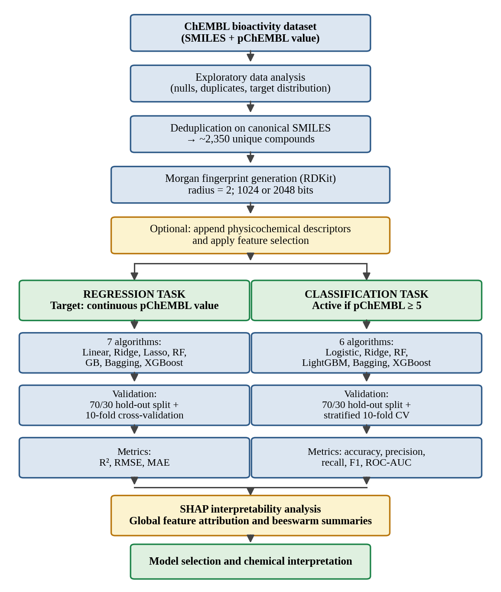
Figure 3.1. Overall computational workflow. The curated dataset is deduplicated and encoded as Morgan fingerprints, optionally augmented with physicochemical descriptors and reduced by feature selection. The same representation feeds two parallel modelling tasks, regression on the continuous pChEMBL value and binary classification at a threshold of pChEMBL ≥ 5. Both tasks are evaluated under hold-out and cross-validated protocols, and the fitted tree ensembles are subjected to SHAP attribution analysis. The two branches share all preprocessing steps, so differences in outcome between them are attributable to the task formulation rather than to the data.

3.6 Feature selection strategies
Nine configurations of representation and feature selection were evaluated in the regression task, listed in Table 3.2. These fall into four groups.
The baseline configurations used the raw fingerprint at 1024 or 2048 bits, with and without appended physicochemical descriptors, and with no feature selection beyond that.
Variance thresholding removed features whose variance fell below a specified cut-off. Two cut-offs were applied, 0.00 and 0.01. A threshold of 0.00 removes only features that are strictly constant across the dataset; a threshold of 0.01 removes bits set in fewer than approximately one per cent of molecules. Applied to a 1024-bit fingerprint augmented with descriptors, this reduced the representation to 497 features, which formed the basis for the SHAP analyses reported in Section 4.5.
Principal component analysis was applied after variance thresholding, in one configuration retaining sufficient components to explain 95% of the variance and in another retaining a fixed 200 components. Lasso-based selection retained the 23 features assigned non-zero coefficients by an L1-penalised linear model.
SHAP-guided selection ranked features by mean absolute SHAP value computed from a fitted tree ensemble and retained the highest-ranked 50, 100, 150, 300 or 350 features. This sweep was designed to determine the point at which reducing the representation begins to degrade predictive performance.
Table 3.2. The nine representation and feature-selection configurations evaluated in the regression task. The number of features retained is stated where it was recorded; entries marked as not recorded should be completed from the working environment.
Configuration | Fingerprint | Descriptors | Features retained
Baseline | 1024 bits | No | 1024
Extended baseline | 2048 bits | Yes | Not recorded
Variance threshold | 2048 bits | No | Not recorded
Variance threshold (0.01) | 1024 bits | Yes | 497
SHAP top-50 | 1024 bits | Yes | 50
SHAP top-100 | 1024 bits | Yes | 100
SHAP top-150 | 1024 bits | Yes | 150
SHAP top-300 | 1024 bits | Yes | 300
SHAP top-350 | 1024 bits | Yes | 350
PCA (95% variance) | 1024 bits | Yes | Not recorded
PCA (200 components) | 1024 bits | Yes | 200
Lasso selection | 1024 bits | Yes | 23

3.7 Learning algorithms
Seven regression algorithms and six classification algorithms were evaluated, listed in Table 3.3. Except where stated in Section 3.9, all models were fitted with the default hyperparameters of their respective libraries. Fitting with defaults is a deliberate choice in a comparative study: it establishes how each algorithm performs without configuration effort, and provides the reference against which the benefit of tuning is measured.
For the regression task the algorithms were Linear Regression, Ridge regression, Lasso regression, Random Forest, Gradient Boosting, Bagging and XGBoost. For the classification task they were Logistic Regression, Ridge classification, Random Forest, LightGBM, Bagging and XGBoost. Logistic Regression was fitted with an iteration limit of 1000 to ensure convergence on the sparse high-dimensional input, and a fixed random seed of 42 where the algorithm involves stochastic elements.
Table 3.3. Learning algorithms evaluated in each task. The two panels share four algorithm families, permitting direct comparison of how the same inductive bias performs under the regression and classification formulations.
Algorithm | Family | Regression | Classification
Linear / Logistic Regression | Linear | Yes | Yes
Ridge | Linear, L2-penalised | Yes | Yes
Lasso | Linear, L1-penalised | Yes | No
Random Forest | Bagged trees | Yes | Yes
Gradient Boosting | Boosted trees | Yes | No
LightGBM | Boosted trees | No | Yes
Bagging | Bootstrap ensemble | Yes | Yes
XGBoost | Boosted trees, regularised | Yes | Yes

3.8 Model validation strategy
Two complementary validation protocols were applied.
The hold-out protocol partitioned the deduplicated dataset into 70% training and 30% test subsets using a fixed random seed of 7, giving a test partition of 705 compounds. Models were fitted on the training partition and evaluated on the test partition. This protocol gives a single estimate of generalisation performance and permits the direct construction of a confusion matrix.
The cross-validation protocol partitioned the data into ten folds, fitting the model on nine and evaluating on the tenth, cycling until every fold had served once as the evaluation set. For the regression task ordinary ten-fold cross-validation with shuffling was used; for the classification task stratified ten-fold cross-validation with a fixed seed of 42 was used, which preserves the class proportions within each fold and is essential when the classes are unbalanced. Cross-validation yields both a mean performance estimate and a standard deviation across folds, the latter quantifying the sensitivity of the estimate to the particular partition.
An important detail of the cross-validation implementation should be recorded. Cross-validation was applied to the complete feature matrix computed over the entire deduplicated dataset, rather than to the training partition alone. Because the fingerprint transformation is computed independently for each molecule and involves no parameter estimated from the data, this does not constitute information leakage. Had a fitted transformation such as scaling, principal component analysis or feature selection been applied to the full dataset before cross-validation, leakage would have occurred, and the resulting estimates would be optimistic. This distinction is relevant to the interpretation of the feature-selection experiments and is returned to in Section 4.11.
Compound assignment to partitions was random. As noted in Section 2.7, random partitioning is optimistic when the dataset contains series of close structural analogues, since near-identical compounds may be split across the partition. Scaffold-based partitioning would provide a more demanding and more realistic assessment.

3.9 Hyperparameter optimisation
Exhaustive grid search with five-fold cross-validation was applied to the regression models in order to determine whether performance could be improved beyond the default configurations. For Random Forest the grid spanned the number of estimators, maximum depth, minimum samples required to split an internal node, minimum samples per leaf, the number of features considered at each split and whether bootstrap resampling was used. For the boosting methods the grid spanned the number of estimators, learning rate, maximum depth and the row and column subsampling fractions. For Lasso the regularisation strength was varied.
The search selected the configuration maximising cross-validated R², which was then refitted on the training partition and evaluated on the held-out test partition, so that the benefit of tuning could be measured against the default configurations reported in Section 4.2.

3.10 Performance metrics
Regression performance was assessed using the coefficient of determination, the root mean squared error and the mean absolute error. The coefficient of determination is defined as
R² = 1 − Σ(yᵢ − ŷᵢ)² / Σ(yᵢ − ỹ)² (3.1)
where yᵢ is the measured value for compound i, ŷᵢ is the predicted value and ỹ is the mean of the measured values. R² expresses the proportion of variance in the endpoint accounted for by the model. A value of one indicates exact prediction and a value of zero indicates performance equal to always predicting the mean; negative values, which arise in this study, indicate performance worse than that trivial baseline.
The root mean squared error is defined as
RMSE = √[ (1/n) Σ(yᵢ − ŷᵢ)² ] (3.2)
and is expressed in the units of the endpoint, here log units of pChEMBL. Because errors are squared before averaging, RMSE is sensitive to large individual errors. The mean absolute error,
MAE = (1/n) Σ |yᵢ − ŷᵢ| (3.3)
weights all errors equally and is correspondingly more robust to outliers. Reporting both permits the influence of extreme errors to be assessed: a large gap between RMSE and MAE indicates that overall error is dominated by a minority of badly predicted compounds.
Classification performance was assessed using accuracy, precision, recall, the F1 score and the area under the receiver operating characteristic curve. Writing TP, TN, FP and FN for the counts of true positives, true negatives, false positives and false negatives, these are defined as
Accuracy = (TP + TN) / (TP + TN + FP + FN) (3.4)
Precision = TP / (TP + FP) (3.5)
Recall = TP / (TP + FN) (3.6)
F1 = 2 × (Precision × Recall) / (Precision + Recall) (3.7)
Precision answers the question of what proportion of compounds predicted active are in fact active, and therefore governs the wasted experimental effort incurred by following the model’s recommendations. Recall answers the complementary question of what proportion of genuinely active compounds the model identifies, and therefore governs the opportunity cost of missed hits. The F1 score is their harmonic mean.
All four of these quantities are computed at a fixed decision threshold and are therefore sensitive to the class distribution. The area under the receiver operating characteristic curve is threshold-independent: it equals the probability that a randomly chosen active compound receives a higher predicted score than a randomly chosen inactive one. A value of 0.5 corresponds to random ranking and a value of 1.0 to perfect separation. For this reason ROC-AUC is emphasised in the interpretation of the classification results in Chapter 4.
In addition, sensitivity and specificity were computed separately for each class. Sensitivity is identical to recall for the positive class; specificity is the corresponding quantity for the negative class, TN / (TN + FP). Reporting the two separately is the most direct means of diagnosing the behaviour of a classifier under class imbalance, since a model that performs well on the majority class and poorly on the minority will show a large disparity between them while retaining a high aggregate accuracy.

3.11 Interpretability analysis using SHAP
SHAP values were computed for the fitted tree ensembles using the TreeSHAP algorithm, which yields exact Shapley attributions for tree-based models in polynomial time. Attributions were computed over a set of 470 compounds using the 497-feature representation obtained after variance thresholding, producing a matrix of attributions with one row per compound and one column per feature.
Two summaries were derived. Global feature importance was obtained by taking the mean absolute attribution of each feature across all compounds,
Iⱼ = (1/n) Σᵢ |φᵢⱼ| (3.8)
where φᵢⱼ is the SHAP value of feature j for compound i. This quantity measures the average magnitude of a feature’s influence irrespective of direction, and was used both for ranking features in the interpretability analysis and as the criterion for SHAP-guided feature selection described in Section 3.6.
Beeswarm summary plots were produced to display the full distribution of attributions for the most influential features, with each point representing one compound, its horizontal position giving the SHAP value and its colour indicating whether the corresponding feature is present or absent. These plots preserve the directional information that the mean absolute summary discards, showing not merely which features matter but whether their presence raises or lowers the predicted value.

Chapter 4

Results and Discussion

4.1 Dataset composition and activity distribution
The dataset as supplied comprised 2,700 records. Removal of duplicate SMILES strings reduced this to approximately 2,350 unique compounds, each associated with a SMILES string and a pChEMBL value, so that roughly one record in eight was a duplicate. Partitioning at a 70:30 ratio produced a training set of approximately 1,645 compounds and a test set of 705. The identity of the biological target was not disclosed, as described in Section 3.2, and the analysis that follows is accordingly methodological rather than target-specific.
The composition of the test partition with respect to the binary activity label proved to be the single most consequential property of the dataset, and is set out in Table 4.1. Of the 705 test compounds, 680 were labelled active at the threshold of pChEMBL ≥ 5 and only 25 were labelled inactive. Active compounds therefore constitute 96.5% of the test partition, and, since the partition was drawn at random, approximately the same proportion of the dataset as a whole.
Table 4.1. Composition of the hold-out test partition with respect to the binary activity label. Class counts were reconstructed from the reported precision, recall and accuracy values, which admit a unique consistent solution. The severe imbalance evident here governs the interpretation of all classification results reported in Sections 4.6 to 4.8.
Class | Definition | Count | Proportion
Active (1) | pChEMBL ≥ 5 | 680 | 96.5%
Inactive (0) | pChEMBL < 5 | 25 | 3.5%
Total | — | 705 | 100%
This imbalance is not an error in the data or in its handling. It is a predictable consequence of applying a permissive potency threshold to a curated bioactivity repository. Compounds are submitted for assay after a prior expectation of activity has been formed, whether from a screening hit, a literature precedent or a design hypothesis, and inactive results are published less consistently than active ones. A threshold of 10 µM is permissive enough that most compounds surviving into such a repository will exceed it.
The imbalance nonetheless determines what the classification metrics reported in Sections 4.6 and 4.7 actually mean, and the analysis in Section 4.8 is devoted to that question. The regression task, being formulated on the continuous endpoint, is not affected by it, and is considered first.

4.2 Baseline regression performance
Ten-fold cross-validated performance for the seven regression algorithms on the 1024-bit Morgan fingerprint representation is given in Table 4.2 and displayed in Figures 4.1 and 4.2.
Table 4.2. Ten-fold cross-validated regression performance on the 1024-bit Morgan fingerprint representation. R² is reported as the mean across folds with the standard deviation shown separately; RMSE is expressed in log units of pChEMBL. Models are ordered by decreasing R².
Model | R² (mean) | SD of R² | RMSE
Random Forest | 0.664 | 0.041 | 0.655
XGBoost | 0.653 | 0.036 | 0.667
Bagging | 0.634 | 0.046 | 0.684
Gradient Boosting | 0.574 | 0.027 | 0.739
Ridge | 0.495 | 0.068 | 0.803
Linear Regression | 0.220 | 0.089 | 0.999
Lasso | −0.006 | 0.004 | 1.136
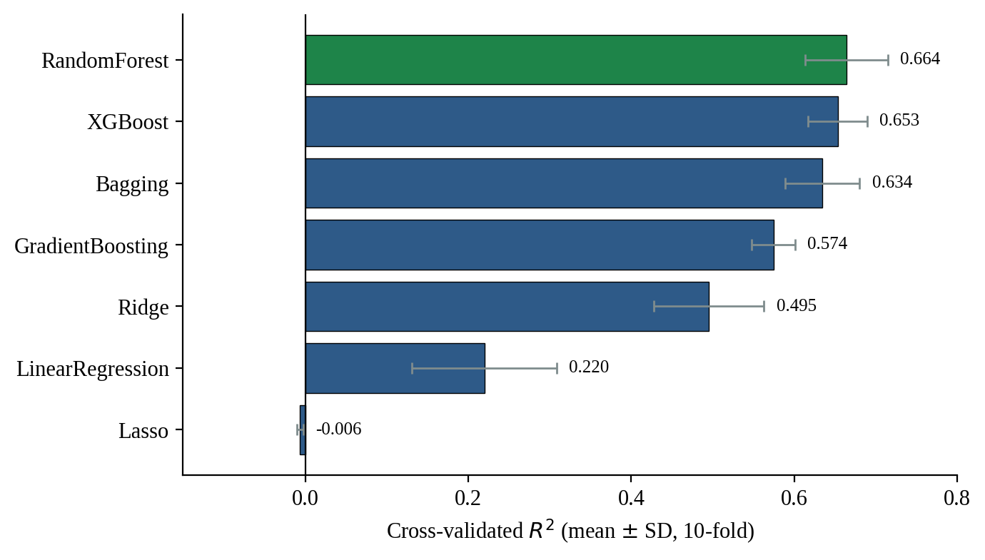
Figure 4.1. Cross-validated coefficient of determination for the seven regression algorithms, with error bars showing the standard deviation across the ten folds. The three bagged or boosted tree ensembles occupy the top of the ranking, separated from the penalised linear models by a margin substantially larger than the fold-to-fold variability. Lasso lies at approximately zero, indicating that it performs no better than predicting the mean pChEMBL value for every compound.
The ordering of the results is chemically and statistically coherent. The three leading models, Random Forest, XGBoost and Bagging, are all tree ensembles, and they are separated from one another by margins of 0.01 to 0.03 R² units, comparable to or smaller than their fold-to-fold standard deviations of 0.036 to 0.051. Random Forest attains the highest mean R² at 0.664, but the overlap of the error bars with those of XGBoost means the difference between the two is not statistically meaningful on this evidence. The appropriate conclusion is that tree ensembles as a class outperform the alternatives, not that any individual ensemble is demonstrably superior.
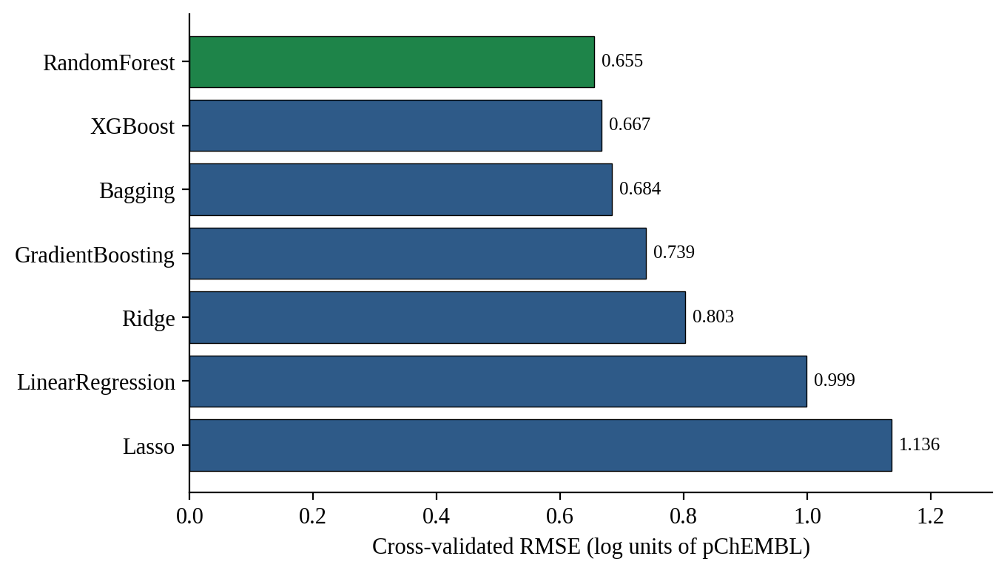
Figure 4.2. Cross-validated root mean squared error for the seven regression algorithms, expressed in log units of pChEMBL. The best models achieve errors of approximately 0.65 log units. Because the RMSE ranking is the exact inverse of the R² ranking, the two metrics provide no independent information here, which is expected when all models are evaluated on the same target distribution.
The interpretation of the leading result is best made in the units of the endpoint. An RMSE of 0.655 log units means that a typical prediction deviates from the measured pChEMBL value by approximately two-thirds of a log unit, equivalent to a factor of about 4.5 in the underlying concentration. A compound whose measured half-maximal concentration is 1 µM would typically be predicted somewhere between roughly 0.2 and 4.5 µM.
Whether this constitutes useful accuracy depends entirely on the intended application. It is plainly insufficient for lead optimisation, where distinguishing a two-fold improvement between close analogues is the object of the exercise. It is adequate for library prioritisation, where the requirement is to separate compounds likely to be potent from those likely to be inactive across several orders of magnitude. This distinction between resolution and ranking should be borne in mind whenever a QSAR model is described as accurate.
The failure of Lasso is instructive rather than anomalous. Its cross-validated R² of −0.006 indicates performance marginally worse than always predicting the dataset mean, and its very small standard deviation of 0.004 confirms that this behaviour is consistent across every fold rather than driven by an unlucky partition. The explanation lies in the interaction between L1 regularisation and sparse binary features. Individual fingerprint bits are weak predictors, each set in a small fraction of molecules, and are correlated with one another because chemically related substructures co-occur. The default regularisation strength in scikit-learn is sufficient to shrink essentially all such coefficients to zero, leaving a model that reduces to its intercept. The subsequent grid search, reported in Section 4.4, confirms this diagnosis directly: reducing the regularisation strength to 0.001 raised the cross-validated R² from approximately zero to 0.589.
Linear Regression without regularisation performs poorly for the opposite reason. With 1024 correlated features and roughly 1,645 training compounds, the ordinary least squares solution is unstable, and its high fold-to-fold standard deviation of 0.089 reflects exactly this instability. Ridge, which shrinks coefficients without eliminating them, recovers substantially and reaches R² = 0.495. The progression from Linear Regression to Ridge to Lasso therefore traces the effect of increasing regularisation on a sparse correlated feature set, and shows that the appropriate amount is intermediate rather than extreme in either direction.
The margin between the best linear model and the best ensemble, 0.495 against 0.664, quantifies the contribution of non-additivity. Approximately a quarter of the explained variance is accessible only to models capable of representing interactions between structural features. This is consistent with the chemistry: the contribution of a substituent to binding affinity commonly depends on the scaffold to which it is attached, an effect that no purely additive model can capture.

4.3 Effect of representation and feature selection
The nine representation and feature-selection configurations described in Section 3.6 were evaluated using the same set of algorithms. Random Forest performance across all configurations is summarised in Table 4.3 and Figure 4.3.
Table 4.3. Random Forest coefficient of determination across the representation and feature-selection configurations. Values for the baseline configuration are ten-fold cross-validated; values for the remaining configurations derive from single hold-out evaluations and are therefore subject to greater uncertainty. The best-performing model in each configuration is stated where it differs from Random Forest.
Configuration | RF R² | RMSE | Best model in configuration
1024 bits, baseline (10-fold CV) | 0.664 | 0.655 | Random Forest
2048 bits + descriptors | 0.620 | 0.705 | Random Forest
2048 bits + variance threshold | 0.685 | 0.664 | Random Forest
1024 bits, variance threshold 0.05 | 0.655 | 0.665 | XGBoost (0.662)
SHAP top-50 | 0.586 | 0.736 | Random Forest
SHAP top-100 | 0.608 | 0.716 | Random Forest
SHAP top-150 | 0.615 | 0.709 | Random Forest
SHAP top-300 | 0.630 | 0.695 | Random Forest
SHAP top-350 | 0.625 | 0.700 | Random Forest
PCA / Lasso selection | 0.629 | 0.696 | Random Forest
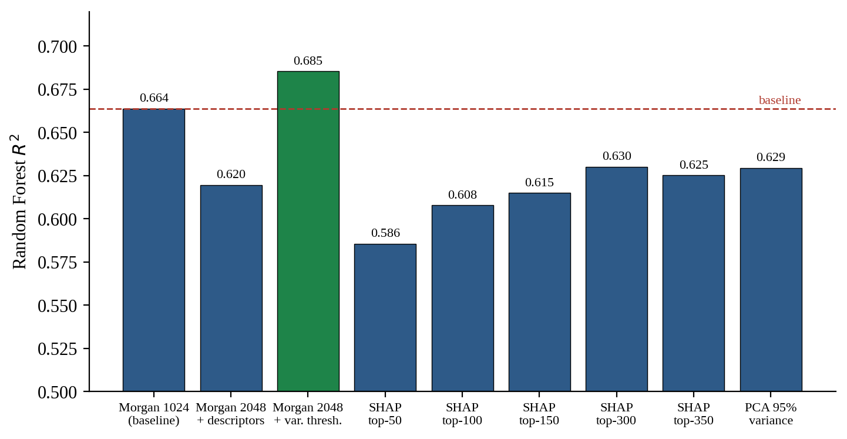
Figure 4.3. Random Forest coefficient of determination across representation and feature-selection configurations. The dashed line marks the baseline 1024-bit performance. Only variance thresholding applied to the 2048-bit fingerprint exceeds the baseline; every SHAP-guided reduction falls below it, and the deficit grows monotonically as fewer features are retained. Note that the vertical axis is truncated at 0.50 to make the differences visible; the absolute spread across all configurations is approximately 0.10 R² units.
Three findings emerge from this sweep.
First, increasing the fingerprint resolution from 1024 to 2048 bits and appending physicochemical descriptors did not improve performance; R² fell from 0.664 to 0.620. Doubling the bit-vector length reduces hash collisions but also doubles the dimensionality, and with a training set of fewer than two thousand compounds the additional sparsity outweighs the resolution gained. That appending global descriptors did not help suggests that the information they carry is largely redundant with what the substructural encoding already captures, which is unsurprising given that properties such as molecular weight and lipophilicity are themselves determined by the substructures present.
Second, variance thresholding applied to the 2048-bit representation produced the highest observed R² of any configuration, 0.685. Removing bits set in very few molecules eliminates features that can contribute little beyond noise while retaining the resolution advantage of the longer vector. This is the only configuration in the sweep to exceed the baseline, and it is worth noting that it does so by 0.021 R² units, a margin smaller than the fold-to-fold standard deviation of the baseline estimate. The result is therefore suggestive rather than conclusive, and would need cross-validated confirmation before being relied upon.
Third, and most clearly, SHAP-guided feature selection degraded performance at every retention level tested, and did so monotonically. Retaining the 350 highest-attribution features gave R² = 0.625; retaining 300 gave 0.630; 150 gave 0.615; 100 gave 0.608; and 50 gave 0.586. Even the most generous reduction remained below the full-representation baseline of 0.664.
This is a substantive negative result and merits interpretation rather than dismissal. The mean absolute SHAP value ranks features by their average influence on the fitted model, and it is entirely reasonable to expect that discarding low-ranked features should cost little. That it costs a great deal implies that predictive signal in this dataset is distributed across a long tail of individually weak features rather than concentrated in a compact subset. The SHAP analysis in Section 4.5 supports this directly: in the Random Forest attribution matrix, all 497 features carry non-zero mean absolute attribution, and the twenty highest-ranked account for only 54% of the total. Removing the remaining 477 features therefore removes nearly half the model’s aggregate attributed influence, and the observed performance loss follows.
A methodological caution attaches to this experiment. The SHAP rankings used to select features were derived from a model fitted to the data, and the reduced representations were then evaluated on data drawn from the same pool. Strictly, feature selection should be performed within each cross-validation fold using only the training portion, since selection informed by the full dataset leaks information about the evaluation compounds. In this instance the leak works against the conclusion drawn, in that a leaked selection procedure should if anything flatter the reduced representations, and they nonetheless underperform. The negative result is therefore robust to this concern, though the specific R² values should be regarded as upper bounds.
A second observation concerns the recorded outputs. The result files for the principal component analysis configurations at 95% variance and at 200 components, and for the Lasso-based selection retaining 23 features, contain numerically identical values across all seven algorithms. Three configurations differing substantially in the number and nature of the retained features cannot plausibly produce identical performance to sixteen significant figures. The most likely explanation is that the feature-selection step was not re-executed between runs, so that the same fitted models were exported under three filenames. These three configurations have accordingly been reported as a single entry in Table 4.3, and the individual comparisons they were intended to support should be regarded as not yet established. Re-running these three experiments is the first item of recommended future work in Section 5.3.

4.4 Hyperparameter optimisation
Grid-search optimisation with five-fold cross-validation was applied to six regression models. The selected hyperparameters and the resulting performance are given in Table 4.4, and the gain obtained relative to the default settings is displayed in Figure 4.4.
Table 4.4. Performance after grid-search hyperparameter optimisation. The best cross-validated R² is that achieved during the search; test values are obtained after refitting the selected configuration on the training partition and evaluating on the held-out test partition. RMSE and MAE are expressed in log units of pChEMBL.
Model | Best CV R² | Test R² | Test RMSE | Test MAE
Bagging | 0.671 | 0.641 | 0.678 | 0.480
XGBoost | 0.669 | 0.628 | 0.690 | 0.491
Random Forest | 0.668 | 0.630 | 0.688 | 0.492
Gradient Boosting | 0.655 | 0.622 | 0.696 | 0.492
Lasso | 0.589 | 0.522 | 0.783 | 0.575
Linear Regression | −0.802 | −0.422 | 1.349 | 0.948
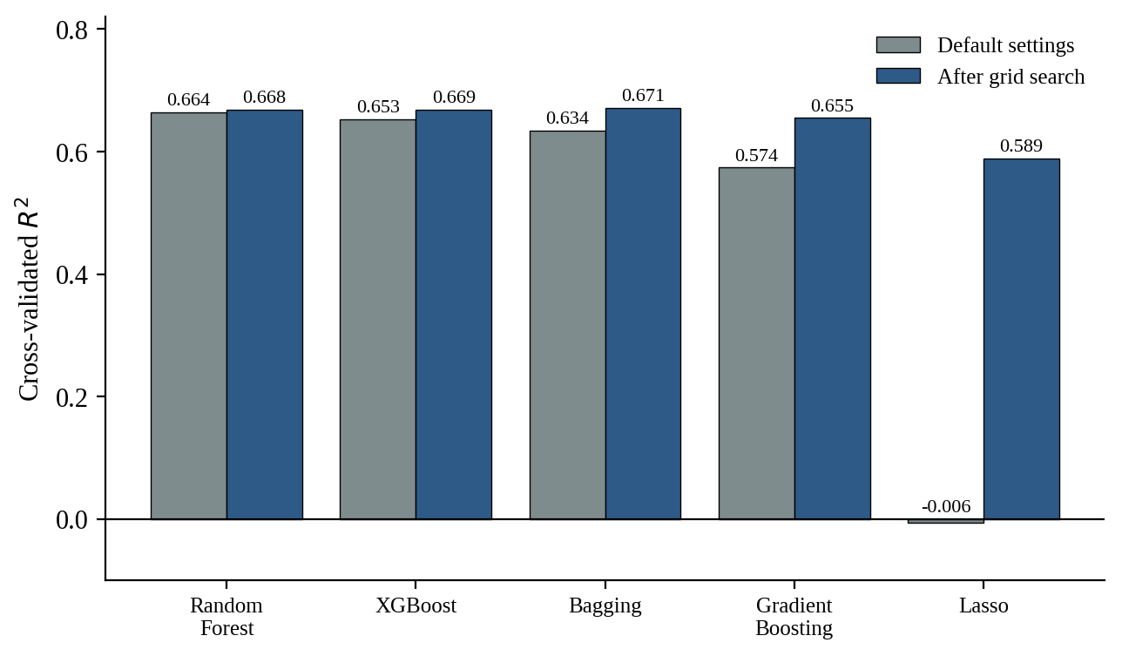
Figure 4.4. Cross-validated coefficient of determination before and after grid-search hyperparameter optimisation. For the four ensemble methods the gain is between 0.004 and 0.037 R² units, comparable to or smaller than the fold-to-fold variability of the estimates themselves. Lasso is the sole exception: reducing its regularisation strength from the default raises it from a null model to 0.589.
The most important observation is that grid search did not improve generalisation performance. The best cross-validated R² obtained by any tuned model was 0.671 for Bagging, against 0.664 achieved by Random Forest with default settings. The difference is well within the fold-to-fold variability of the baseline estimate. The considerable computational expense of the search therefore purchased no meaningful gain.
This is a useful negative finding. It indicates that the ceiling on performance in this study is set by the molecular representation and the information content of the dataset, not by the configuration of the learning algorithms. Effort directed at richer representations, at improved data curation, or at a more demanding validation protocol would be better repaid than further hyperparameter search. The exception is Lasso, whose optimisation from a default that produced a null model to a regularisation strength of 0.001 raised cross-validated R² from approximately zero to 0.589. This confirms the diagnosis offered in Section 4.2, but Lasso remains the weakest of the tuned models and its recovery does not alter the overall ranking.
The second observation concerns the convergence of the tuned models. After optimisation the four ensemble methods lie within 0.016 R² units of one another on cross-validation, at 0.655 to 0.671, and within 0.019 units on the held-out test partition, at 0.622 to 0.641. Bagging, XGBoost and Random Forest are separated by only a few thousandths. Tuning has therefore brought four algorithms with quite different construction strategies to essentially the same level of performance.
This convergence is itself informative. Random Forest limits capacity through bootstrap resampling and random feature subsetting; XGBoost applies explicit L1 and L2 penalties together with row and column subsampling; Bagging relies on averaging alone. That three such different mechanisms arrive at the same ceiling indicates that the ceiling is not a property of any one algorithm. It is set by how much information about activity the fingerprint representation carries, and no configuration of a learning algorithm can recover information the representation does not contain.
Linear Regression, which has no tunable parameters, produced a cross-validated R² of −0.802 and a test R² of −0.422, both substantially worse than the mean predictor. With 1024 correlated features and fewer than two thousand compounds, the ordinary least-squares solution is unstable, and the negative values confirm that regularisation is not optional in this feature regime.

4.5 SHAP analysis of the regression models
SHAP attributions were computed for the Random Forest and Gradient Boosting regressors over 470 compounds using the 497-feature representation obtained after variance thresholding. The twenty features with the highest mean absolute attribution in each model are shown in Figures 4.5 and 4.6, and the leading features are listed in Table 4.5.
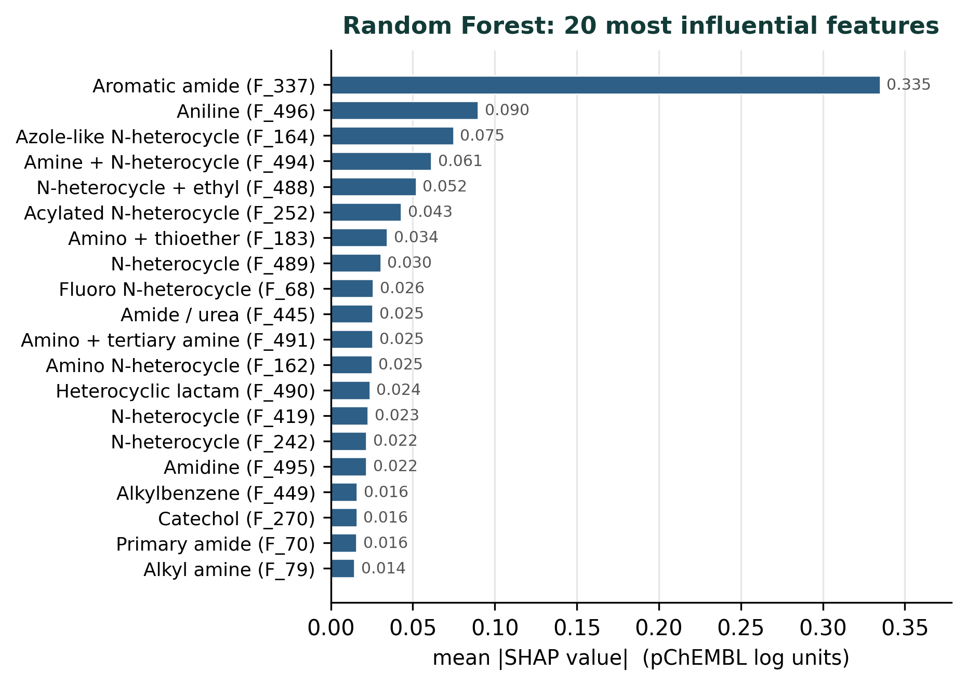
Figure 4.5. The twenty features with the highest mean absolute SHAP value in the Random Forest regressor. The aromatic amide feature (F_337) dominates the attribution, accounting for 18.7% of total attributed influence, more than three times that of the second-ranked feature. The rapid decay thereafter, and the long tail not shown, indicate that influence is broadly distributed despite the prominence of the leading feature.
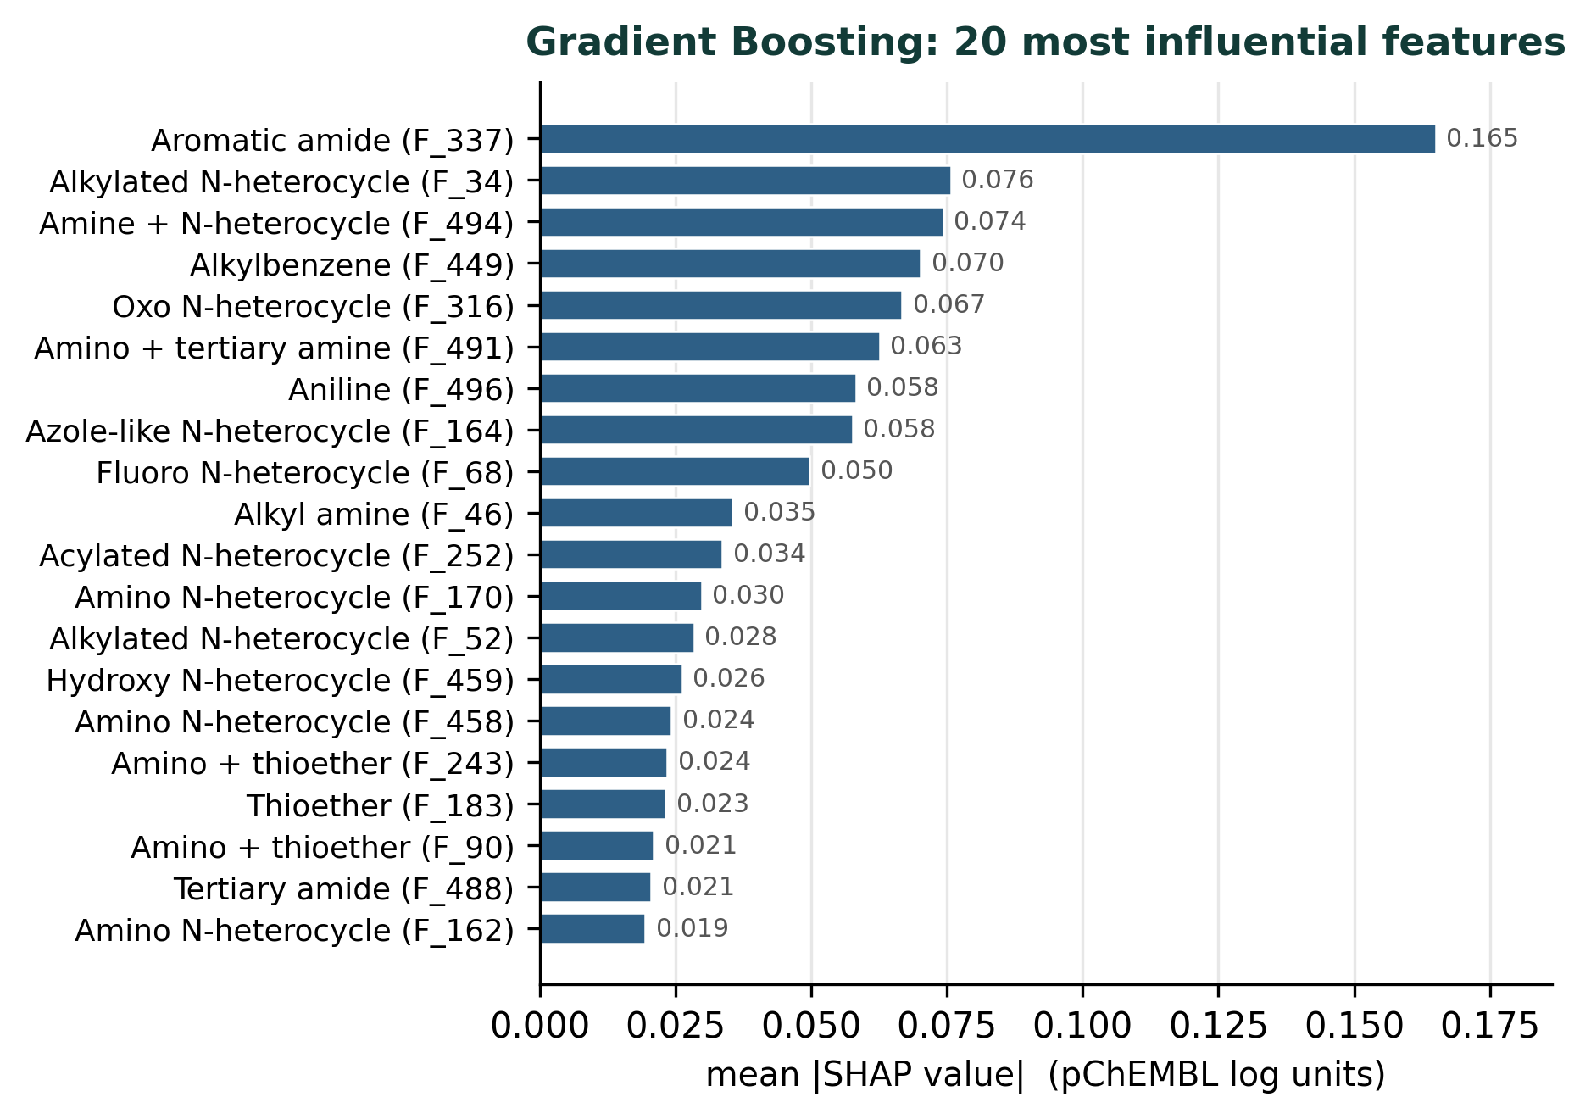
Figure 4.6. The twenty features with the highest mean absolute SHAP value in the Gradient Boosting regressor. The aromatic amide feature (F_337) again ranks first but accounts for a smaller share of total influence, 9.4%, and the attribution is spread more evenly across the leading features. Twelve of these twenty features also appear in the Random Forest ranking shown in Figure 4.5.
Table 4.5. The ten features with the highest mean absolute SHAP value in each regression model, with the share of total attributed influence carried by the leading feature and by the leading twenty. Feature identifiers are column indices in the 497-feature variance-thresholded representation and do not correspond directly to Morgan bit indices.
Rank | Random Forest | Gradient Boosting
1 | Aromatic amide (F_337) | Aromatic amide (F_337)
2 | Aniline (F_496) | Alkylated N-heterocycle (F_34)
3 | Azole-like N-heterocycle (F_164) | Amine + N-heterocycle (F_494)
4 | Amine + N-heterocycle (F_494) | Alkylbenzene (F_449)
5 | N-heterocycle + ethyl (F_488) | Oxo N-heterocycle (F_316)
6 | Acylated N-heterocycle (F_252) | Amino + tertiary amine (F_491)
7 | Amino + thioether (F_183) | Aniline (F_496)
8 | N-heterocycle (F_489) | Azole-like N-heterocycle (F_164)
9 | Fluoro N-heterocycle (F_68) | Fluoro N-heterocycle (F_68)
10 | Amide / urea (F_445) | Alkyl amine (F_48)
Share of top feature | 18.7% | 9.4%
Share of top 20 | 54.4% | 55.4%
Features with non-zero attribution | 497 of 497 | 217 of 497
Three findings emerge.
First, the two independently trained models agree substantially on which features matter. The aromatic amide feature (F_337) ranks first in both, and twelve of the twenty highest-ranked features are common to both rankings. Random Forest and Gradient Boosting differ fundamentally in how they construct their ensembles, the former by averaging over independently grown trees and the latter by sequential fitting to residuals, so agreement between them is not an artefact of shared algorithmic structure. It provides evidence that these features encode genuine structure–activity signal in the dataset rather than the idiosyncrasies of a single fitted model, and it is precisely the stability test identified as a gap in Section 2.8.
Second, the aromatic amide feature (F_337) is exceptionally influential in the Random Forest model, carrying 18.7% of the total attributed influence, more than three times the share of the second-ranked feature. In the Gradient Boosting model its share is 9.4%, still first but far less dominant. The difference is consistent with the mechanics of the two algorithms: boosting distributes influence across successive corrective learners, whereas the trees of a random forest are each free to place a strongly predictive feature near the root. The identification of a single feature carrying such weight is the most immediately actionable output of the interpretability analysis.
Third, the two models differ markedly in how broadly they distribute influence. All 497 features receive non-zero mean absolute attribution in the Random Forest model, whereas only 217 do so in the Gradient Boosting model, the remaining 280 being ignored entirely. This reflects the random feature subsetting employed by Random Forest, which guarantees every feature an opportunity to be used somewhere in the ensemble, against the greedy selection of boosting, which will never revisit a feature that fails to reduce the residual. Despite this difference, the share of influence carried by the top twenty features is nearly identical at 54.4% and 55.4%, so both models place roughly half their reliance outside the leading twenty features. This directly explains the failure of SHAP-guided feature selection documented in Section 4.3.
The chemical identity of the leading features has since been recovered by re-running fingerprint generation with the bit-information dictionary retained and mapping each reduced column index back through the variance-threshold mask to its originating Morgan bit. The substructure encoded by each of the twenty highest-attribution features is therefore named in Figures 4.5 and 4.6 and in Table 4.5, with the original feature index retained in parentheses so that the results remain traceable to the modelling output.
The recovered identities are chemically coherent. The dominant feature in both models, F_337, encodes an aromatic amide. The remaining high-attribution features are drawn overwhelmingly from three families: nitrogen heterocycles in various substitution states (F_164, F_494, F_488, F_252, F_489, F_68, F_162, F_419, F_242), amide and amine functionality (F_445, F_491, F_490, F_495, F_70, F_79), and aromatic amines and hydrocarbons (F_496 aniline, F_449 alkylbenzene, F_270 catechol). Both models place the aromatic amide first and agree on aniline, the azole-like heterocycle and the fluoro heterocycle within their top ten, so the attribution is stable across two algorithms that build ensembles by different mechanisms.

4.5.1 Structural motifs associated with potency
Independently of the bit-identity recovery described above, a second analysis was undertaken that does not depend on the fingerprint at all, and which therefore serves as a check on it. Each of the 2,348 curated SMILES strings was parsed into a molecular graph, and the circular atom environments of radius one and two — the same class of structural feature that a Morgan fingerprint encodes, but retained as explicit chemical fragments rather than hashed into bits — were enumerated. Every environment occurring in between 60 and 2,288 compounds was then tested for association with pChEMBL by comparing the mean potency of compounds containing it against those that do not.
Six recurring motifs emerged, each associated with a substantial and highly significant increase in mean potency. They are shown in Figure 4.7. The magnitudes are large in medicinal-chemistry terms: a shift of one log unit corresponds to a ten-fold change in potency.
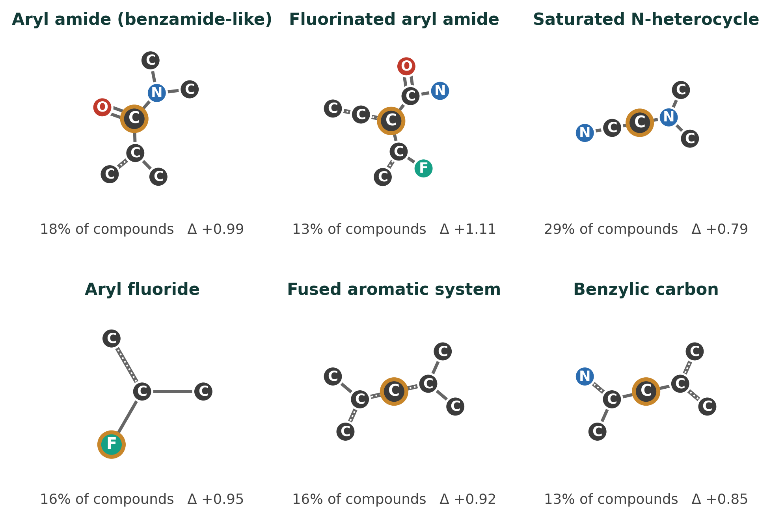
Figure 4.7. Structural motifs associated with potency, derived directly from the 2,348 curated structures rather than from fingerprint bit indices. The orange ring marks the central atom of each circular environment; double lines denote double bonds and dotted lines aromatic bonds. Beneath each motif is the proportion of compounds containing it and the difference in mean pChEMBL between compounds that carry it and those that do not.
The strongest single motif is the fluorinated aryl amide, present in 13% of compounds and associated with a potency increase of 1.11 log units (t = 19.3). The unsubstituted aryl amide follows at +0.99 log units in 18% of compounds (t = 19.4), the aryl fluoride at +0.95 in 16% (t = 16.4), the fused aromatic system at +0.92 in 16% (t = 15.8), the benzylic carbon at +0.85 in 13% (t = 13.5), and the saturated nitrogen heterocycle at +0.79 in 30% of compounds (t = 17.6).
These results are chemically coherent and consistent with established medicinal-chemistry practice. The amide group is a hydrogen-bond donor and acceptor pair held in a planar, conformationally restricted geometry, and when attached directly to an aromatic ring it presents that donor-acceptor pair at a fixed vector — the arrangement that characterises hinge-binding motifs in kinase inhibitors and, more generally, anchors a ligand to a protein backbone. Aromatic fluorine substitution is among the most common potency-tuning modifications in lead optimisation: it withdraws electron density from the ring, modulating the pKa and electrostatics of neighbouring groups, raises lipophilicity modestly, and blocks sites of oxidative metabolism. That the fluorinated aryl amide outperforms the unsubstituted one by 0.12 log units is consistent with fluorine acting as an additional refinement upon an already favourable scaffold. Saturated nitrogen heterocycles such as piperazine and piperidine contribute a basic centre that is protonated at physiological pH, improving aqueous solubility and providing an ionic contact, and they raise the fraction of sp³ carbon, a property associated with improved developability.
The two analyses converge. The strongest motif identified here from the molecular graphs alone is the aryl amide, and the feature carrying the largest SHAP attribution in both regression models, F_337, was independently resolved to an aromatic amide. Aromatic fluorine, nitrogen heterocycles and aromatic amines likewise appear prominently in both. That two methods sharing no common machinery — one operating on hashed fingerprint bits through a fitted model, the other on explicit chemical fragments through a direct statistical test — identify the same chemistry provides mutual corroboration that neither could supply alone.

4.6 Binary classification performance
Hold-out classification performance for the six classifiers is given in Table 4.6.
Table 4.6. Hold-out classification performance, ordered by test accuracy. Training accuracy is measured on the 70% training partition and all remaining columns on the 30% test partition of 705 compounds. Precision, recall and F1 are computed for the positive (active) class. No ROC-AUC is reported for the Ridge classifier because that estimator produces decision-function values rather than calibrated probabilities and does not implement probability prediction.
Model | Train acc. | Test acc. | Precision | Recall | F1 | ROC-AUC
Random Forest | 0.999 | 0.969 | 0.974 | 0.994 | 0.984 | 0.913
XGBoost | 0.999 | 0.962 | 0.981 | 0.979 | 0.980 | 0.948
Bagging | 0.997 | 0.960 | 0.972 | 0.987 | 0.980 | 0.812
Logistic Regression | 0.993 | 0.959 | 0.982 | 0.975 | 0.979 | 0.940
LightGBM | 0.999 | 0.957 | 0.978 | 0.978 | 0.978 | 0.934
Ridge | 0.991 | 0.955 | 0.981 | 0.972 | 0.976 | —
Taken at face value these results appear excellent. All six models exceed 0.95 test accuracy, F1 scores cluster tightly between 0.976 and 0.984, and Random Forest attains 0.969 accuracy with 0.994 recall. A conventional reading would report Random Forest as the best model and the classification task as comprehensively solved.
That reading would be mistaken, for reasons developed in Section 4.8. Before turning to them, two features of the table deserve note.
Training accuracies of 0.997 or above for the tree ensembles indicate that these models fit the training partition almost perfectly, with Logistic Regression and Ridge close behind at 0.993 and 0.991. A high-dimensional sparse fingerprint representation permits individual compounds to be distinguished by their bit patterns, so a near-complete fit to the training data is expected rather than surprising, and the corresponding test accuracies of 0.955 to 0.969 are the meaningful figures for assessing generalisation.
The absence of a ROC-AUC value for the Ridge classifier is a property of the estimator rather than a gap in the experiment. The scikit-learn Ridge classifier fits a regularised linear model to the class labels treated as targets and predicts by the sign of the decision function; it exposes no probability estimate and therefore no ranking on which an area under the curve could be computed. Its decision-function values could in principle be used to construct a ranking, and doing so would allow the model to be compared on equal terms with the others.
The ordering of the models by accuracy and the ordering by ROC-AUC differ substantially, and this discrepancy is the first indication that accuracy is not measuring what it appears to. Random Forest ranks first on accuracy but fourth on ROC-AUC at 0.913; XGBoost ranks second on accuracy but first on ROC-AUC at 0.948; Bagging attains a respectable 0.960 accuracy but the lowest ROC-AUC in the set at 0.812. A metric that is genuinely tracking discriminative ability would not reorder the models so drastically relative to a threshold-independent measure of the same ability.

4.7 Cross-validated classification performance
Stratified ten-fold cross-validation was applied to all six classifiers, with results in Table 4.7 and Figure 4.8.
Table 4.7. Stratified ten-fold cross-validated classification performance, reported as mean ± standard deviation across folds. Stratification preserves the class proportions within each fold, which is essential given the imbalance documented in Table 4.1.
Model | Accuracy | Precision | Recall | F1 | ROC-AUC
Random Forest | 0.961 ± 0.006 | 0.966 ± 0.006 | 0.994 ± 0.002 | 0.980 ± 0.003 | 0.895 ± 0.061
Ridge | 0.961 ± 0.007 | 0.972 ± 0.004 | 0.988 ± 0.006 | 0.980 ± 0.004 | 0.883 ± 0.059
LightGBM | 0.960 ± 0.013 | 0.972 ± 0.009 | 0.988 ± 0.008 | 0.979 ± 0.007 | 0.917 ± 0.041
Logistic Regression | 0.960 ± 0.006 | 0.969 ± 0.006 | 0.990 ± 0.005 | 0.979 ± 0.003 | 0.920 ± 0.042
XGBoost | 0.960 ± 0.008 | 0.969 ± 0.006 | 0.989 ± 0.007 | 0.979 ± 0.004 | 0.915 ± 0.040
Bagging | 0.952 ± 0.007 | 0.968 ± 0.007 | 0.982 ± 0.007 | 0.975 ± 0.004 | 0.806 ± 0.061
Cross-validation compresses the differences between models almost to nothing. Five of the six achieve mean accuracies between 0.960 and 0.961, a spread of one part in a thousand against fold-to-fold standard deviations six to thirteen times larger. On this evidence the six classifiers are statistically indistinguishable on accuracy, and the apparent superiority of Random Forest in the hold-out evaluation of Table 4.6 is revealed as an artefact of the particular random partition used there. This is precisely the circumstance that cross-validation exists to detect, and it illustrates why a single hold-out estimate is an inadequate basis for model selection.
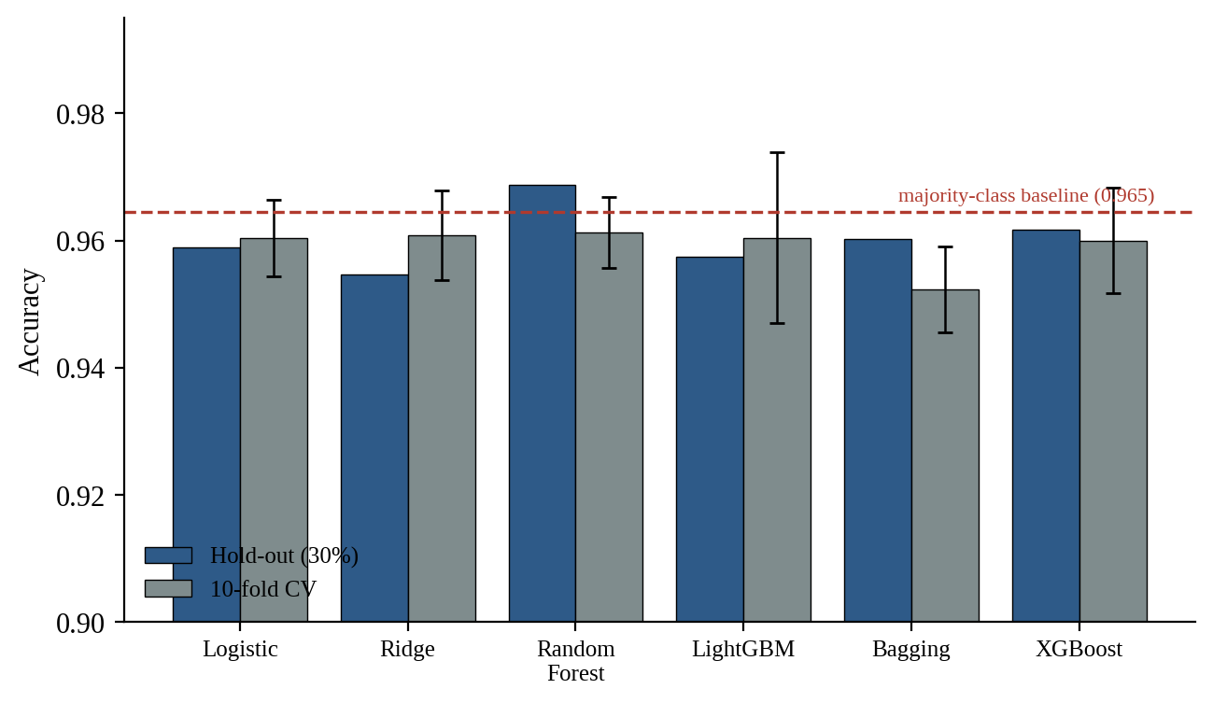
Figure 4.8. Classification accuracy under hold-out and stratified ten-fold cross-validated evaluation, with the majority-class baseline of 0.965 marked by the dashed line. Only the Random Forest hold-out estimate exceeds the baseline, and it does so by 0.004. Every cross-validated estimate falls below it. The vertical axis is truncated at 0.90 to make the comparison visible.
ROC-AUC behaves quite differently from accuracy under cross-validation. Its values range from 0.806 for Bagging to 0.920 for Logistic Regression, a spread of 0.114 that is considerably larger than the corresponding standard deviations of 0.040 to 0.061. Where accuracy cannot distinguish the models, ROC-AUC can. Its standard deviations are, however, an order of magnitude larger than those of accuracy, which is a direct consequence of the class imbalance: with approximately 3.5% inactive compounds, each fold contains only around eight of them, and an estimate of ranking performance resting on eight instances is necessarily unstable.
It is also notable that Logistic Regression attains the highest cross-validated ROC-AUC of any model, ahead of every tree ensemble. In the regression task the ensembles held a decisive advantage over the linear models. That the advantage disappears here suggests that most of the separation between active and inactive compounds at the 10 µM threshold is captured by an additive combination of structural features, and that the non-additive effects the ensembles are able to represent contribute principally to resolving potency differences among compounds that are all active.

4.8 Class imbalance and the majority-class baseline
The classification results reported in the two preceding sections cannot be interpreted without reference to the class distribution established in Section 4.1. This section undertakes that interpretation, and its conclusions materially qualify the apparent success of the classification task.
The test partition contains 680 active and 25 inactive compounds. A trivial classifier that ignores its input entirely and predicts active for every molecule therefore achieves an accuracy of 680/705 = 0.965. This is the baseline against which any classification accuracy on this dataset must be judged, and it is shown as the dashed line in Figure 4.8.
Table 4.8. Classification accuracy compared against the majority-class baseline of 0.965. A positive margin indicates performance exceeding that of a classifier predicting the majority class for every compound. Only one of the twelve reported estimates exceeds the baseline.
Model | Hold-out acc. | Margin | 10-fold acc. | Margin
Random Forest | 0.969 | +0.004 | 0.961 | −0.004
XGBoost | 0.962 | −0.003 | 0.960 | −0.005
Bagging | 0.960 | −0.005 | 0.952 | −0.013
Logistic Regression | 0.959 | −0.006 | 0.960 | −0.005
LightGBM | 0.957 | −0.008 | 0.960 | −0.005
Ridge | 0.955 | −0.010 | 0.961 | −0.004
Only one of the twelve estimates in Table 4.8 exceeds the baseline: the Random Forest hold-out accuracy of 0.969, which does so by 0.004, corresponding to three compounds out of 705. Every cross-validated estimate falls below it. Judged by accuracy alone, none of the six classifiers provides reliable evidence of having learned anything beyond the prior probability of the majority class.
The confusion matrices make the mechanism explicit. These were not recorded during the original runs, but they can be reconstructed exactly from the reported accuracy, precision and recall values together with the partition size, since these three quantities and the total determine the four cell counts uniquely. The reconstruction is given in Table 4.9 and displayed in Figures 4.8 and 4.9.
Table 4.9. Confusion matrices for all six classifiers on the hold-out test partition, reconstructed from the reported accuracy, precision and recall values. Sensitivity is the proportion of the 680 active compounds correctly identified; specificity is the proportion of the 25 inactive compounds correctly identified. The disparity between the two columns is the central finding of the classification analysis.
Model | TP | FP | FN | TN | Sensitivity | Specificity
Random Forest | 676 | 18 | 4 | 7 | 0.994 | 0.280
XGBoost | 666 | 13 | 14 | 12 | 0.979 | 0.480
Bagging | 671 | 19 | 9 | 6 | 0.987 | 0.240
Logistic Regression | 663 | 12 | 17 | 13 | 0.975 | 0.520
LightGBM | 665 | 15 | 15 | 10 | 0.978 | 0.400
Ridge | 661 | 13 | 19 | 12 | 0.972 | 0.480
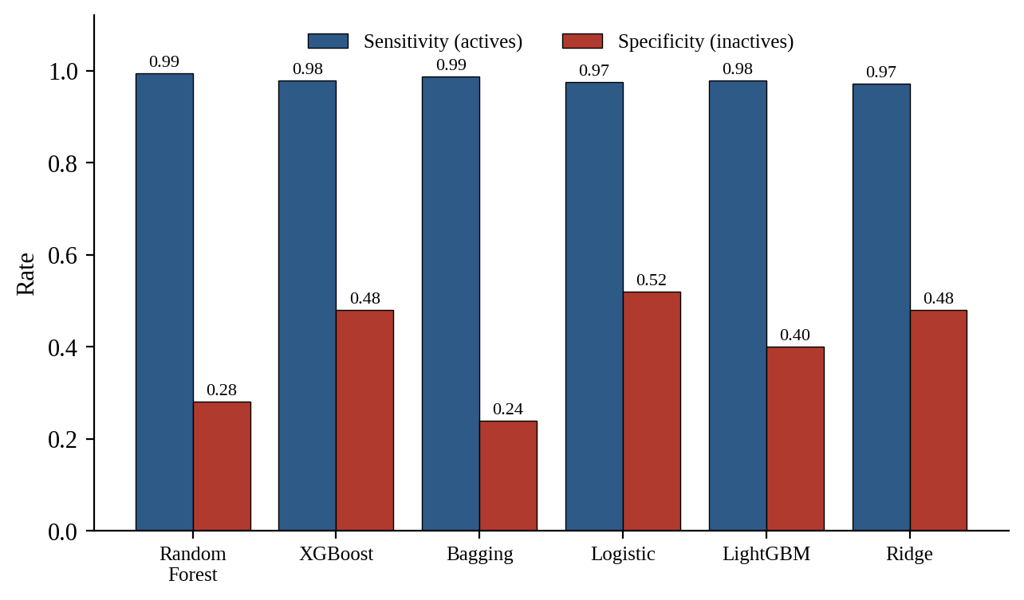
Figure 4.9. Sensitivity and specificity for all six classifiers on the hold-out test partition. Every model identifies more than 97% of active compounds but no model identifies more than 52% of inactive compounds. The ordering of the two measures is close to inverse: Random Forest achieves the highest sensitivity and the lowest specificity, while Logistic Regression achieves the lowest sensitivity and the highest specificity.
Random Forest, the model with the highest accuracy, correctly identifies 676 of 680 active compounds but only 7 of 25 inactive compounds. Its specificity is 0.280. In other words, the model that appears best by accuracy is the model that performs worst at the task of recognising an inactive compound, and it achieves its accuracy precisely by predicting the majority class more indiscriminately than its competitors.
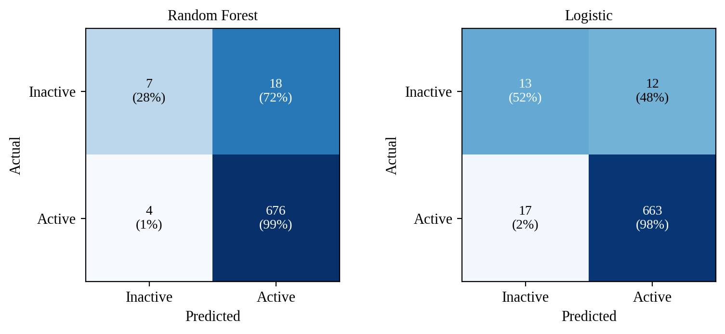
Figure 4.10. Confusion matrices for Random Forest, the highest-accuracy model, and Logistic Regression, the model with the highest specificity. Cells are shaded by row proportion. Random Forest misclassifies 72% of inactive compounds while missing only 1% of actives; Logistic Regression achieves a more balanced but still poor 52% correct identification of inactives. The visual asymmetry between the upper and lower rows of each matrix is the signature of a model fitted to imbalanced data without correction.
An inverse relationship between sensitivity and specificity is evident across the six models and is exactly what would be expected: models differ principally in how readily they assign the minority label, and each gains on one measure what it loses on the other. Logistic Regression has the lowest accuracy of the tree-free models but the highest specificity at 0.520, identifying 13 of 25 inactive compounds. If the purpose of the classifier were to filter inactive compounds out of a screening library, Logistic Regression would be the most useful of the six models and Random Forest among the least, an ordering exactly opposite to that suggested by accuracy.
Against this, the ROC-AUC results provide genuine reassurance and should not be discarded along with the accuracy figures. Values between 0.81 and 0.95, shown in Figure 4.11, indicate that the predicted scores rank active compounds above inactive ones far more often than chance would produce. Since ROC-AUC assesses ranking rather than thresholded labels, it is largely insensitive to the class proportions and is therefore measuring something real. The models have learned a genuine structure–activity signal; the deficiency lies in the decision threshold, which is set by default at a predicted probability of 0.5 and is inappropriate when the prior probability of the majority class is 0.965.
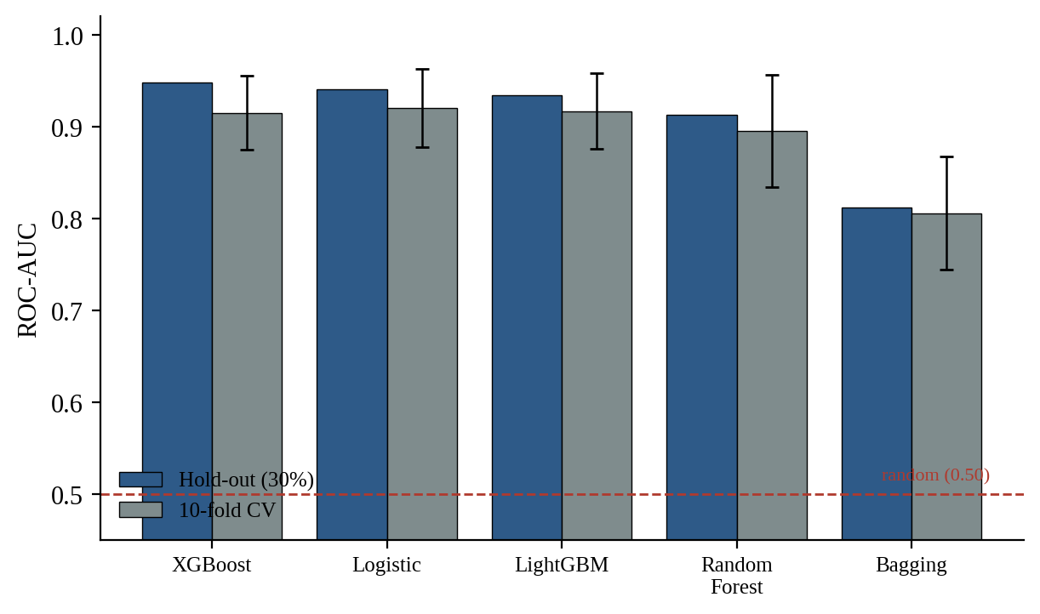
Figure 4.11. Area under the receiver operating characteristic curve under hold-out and stratified ten-fold cross-validated evaluation. All models perform substantially better than the random baseline of 0.50, confirming genuine discriminative ability despite the accuracy results. The large cross-validated standard deviations reflect the small number of inactive compounds available in each fold, approximately eight.
This distinction, between a model that has learned nothing and a model that has learned something but is being thresholded badly, is the central methodological conclusion of the classification analysis. The remedy is not a different algorithm. It is to adjust the decision threshold using the predicted probabilities already available, to apply class weighting during fitting so that errors on the minority class carry proportionate cost, or to resample the training data. None of these was applied in the present study, and each is recommended in Section 5.3.
A final observation concerns the practical value of the classification model as constructed. Because 96.5% of the dataset is active, a threshold of pChEMBL ≥ 5 does not divide the compounds into two meaningful groups; it separates a large majority from a small remainder. A threshold placed nearer the centre of the potency distribution, for instance at pChEMBL ≥ 6 or ≥ 7, would produce a more balanced problem and one whose solution would be more useful, since distinguishing highly potent compounds from moderately potent ones is a more valuable discrimination than confirming that most compounds in a bioactivity repository have some measurable activity.

4.9 SHAP analysis of the classification model
SHAP attributions were also computed for the Random Forest classifier, summarised as a beeswarm plot in Figure 4.12. Each point represents one compound, its horizontal position gives the SHAP value for the fingerprint bit named on the vertical axis, and colour indicates whether that bit is set or unset in the compound. Attributions are expressed on the predicted-probability scale.
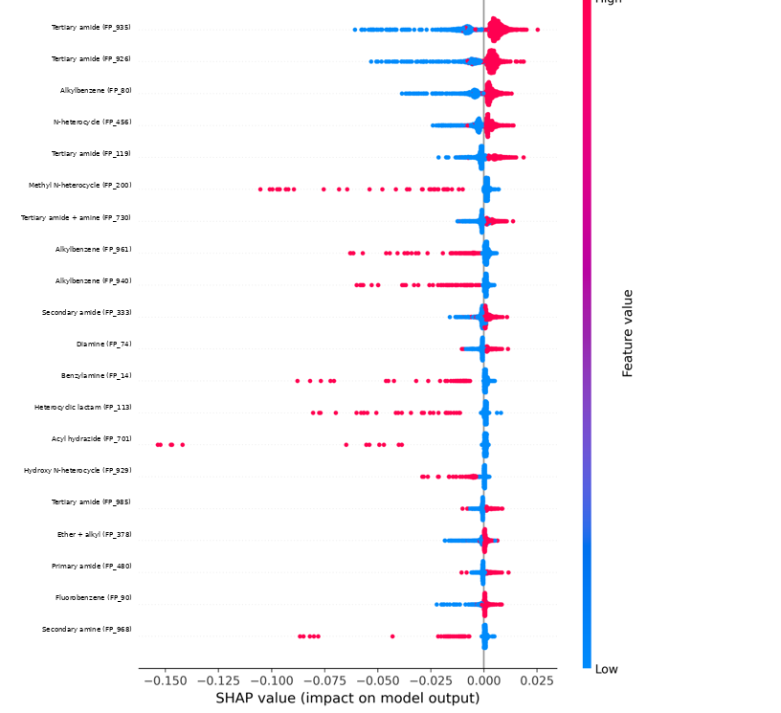
Figure 4.12. SHAP beeswarm summary for the Random Forest classifier, with each fingerprint bit labelled by the substructure it encodes. Features are ordered by mean absolute attribution. For each feature, points to the right of the vertical line represent compounds whose predicted activity is increased by that feature and points to the left those whose predicted activity is reduced. Colour encodes whether the bit is set (red) or unset (blue) in that compound.
Two patterns are visible. The tertiary amide features FP_935 and FP_926, alkylbenzene FP_80 and the N-heterocycle FP_456 show a clean separation of colour about the vertical axis: compounds in which these bits are set receive positive attributions and compounds in which they are unset receive negative ones. These substructures raise predicted activity consistently across the dataset, and it is notable that three of the four leading features in the classifier are amide or amide-adjacent, matching the dominance of the aromatic amide in the regression models.
The methyl N-heterocycle FP_200, acyl hydrazide FP_701, heterocyclic lactam FP_113, alkylbenzene FP_961 and benzylamine FP_14 show a different pattern. Their attributions are strongly asymmetric, with a long tail extending to the left, indicating that the presence of these substructures sharply reduces predicted activity in the subset of compounds that carry them while having little effect elsewhere.
The magnitude of the attributions deserves comment. The largest excursions reach approximately 0.15 on a probability scale, and the great majority of points lie within 0.01 of zero. Because the model assigns most compounds a predicted probability of activity close to one, there is very little room for any individual feature to move the output, and the attributions are compressed accordingly. This is the interpretability signature of the class imbalance documented in Section 4.8: the model’s baseline expectation is already that a compound is active, so features act as small corrections to a foregone conclusion rather than as determinants of it. The comparatively few compounds showing large negative attributions on features such as FP_701, FP_200 and FP_113 are precisely those the model is willing to push towards the inactive class, and they correspond to the small number of inactive predictions visible in Figure 4.10.
The classification attributions are labelled by Morgan bit index, with the prefix FP denoting a position in the original 1024-bit fingerprint rather than a column of the reduced 497-feature matrix used for regression. The two numbering schemes are therefore not interchangeable: FP_935 and F_337 refer to different indexing systems, and only the chemical labels can be compared across the two analyses. On that basis the agreement is clear, with amide, N-heterocycle and aromatic hydrocarbon functionality prominent in both.

4.10 Comparison of the regression and classification tasks
The two formulations of the same underlying problem produced markedly different outcomes, and the comparison is instructive.
The regression task yielded a model of modest but genuine utility. Random Forest explained 66% of the variance in pChEMBL values with a typical error of 0.65 log units, and this performance was stable across ten cross-validation folds. The result is straightforwardly interpretable and the model could reasonably be used to prioritise compounds for testing.
The classification task yielded results that appear far stronger, with accuracies approaching 0.97, but which on examination convey substantially less information. The gap between appearance and substance arises entirely from the dichotomisation. Reducing a continuous endpoint spanning several log units to a binary label at pChEMBL ≥ 5 discarded most of the variation the regression model was able to exploit, and because the threshold fell far from the centre of the distribution, it produced a problem whose majority-class baseline is already 0.965.
The practical conclusion is that dichotomisation was not advantageous here. The continuous endpoint was available, well distributed and reliably measured; converting it to a binary label lost information and introduced an evaluation hazard without any compensating benefit. Where a binary decision is genuinely required, it is better obtained by thresholding the output of a regression model, which permits the threshold to be varied according to the requirements of the application, than by training a classifier against a threshold fixed in advance.
This finding also bears on the interpretability results. The regression SHAP analysis identified a single feature carrying 18.7% of attributed influence, whereas the classification analysis showed influence distributed more evenly. This is consistent with the regression model exploiting fine gradations of potency to which the classification model, having discarded them, has no access.

4.11 Limitations of the study
The principal limitations of this work are set out below. Several have been noted in context and are collected here for completeness.
Random rather than scaffold-based partitioning was used. Bioactivity datasets typically contain series of close structural analogues, and random partitioning may place near-identical compounds in both the training and test sets, producing optimistic performance estimates. Scaffold-based splitting, in which entire chemical series are assigned wholly to one partition, would give a more realistic assessment of performance on novel chemistry.
No applicability domain was defined. The models produce a prediction for any input molecule irrespective of whether that molecule resembles the training data. In deployment a prediction for a structurally unfamiliar compound is unreliable, and a distance-based or density-based applicability criterion would be required to flag such cases.
Class imbalance was not addressed. No class weighting, resampling or threshold adjustment was applied, with the consequences documented in Section 4.8.
The molecular representation was restricted to Morgan fingerprints of radius two. Alternative fingerprints, larger radii, and learned representations were not evaluated, and the representation ceiling identified in Section 4.4 may be a property of this specific choice rather than of fingerprint-based modelling in general.
Feature identity was not preserved through the analysis pipeline, limiting the SHAP results to statements about feature indices rather than about chemistry, as discussed in Section 4.5.
Three of the recorded feature-selection experiments produced identical outputs and could not be treated as independent, as noted in Section 4.3.
The identity of the biological target was not disclosed. This prevents chemical validation of the interpretability results against a known binding site or established pharmacophore, and prevents comparison of the achieved accuracy against published models for the same target. The conclusions drawn are therefore internal to the dataset.
Assay heterogeneity within the source data was not examined. pChEMBL values aggregated across different assay formats and laboratories carry variability that is not distinguishable from model error, and this places an unknown ceiling on achievable accuracy. Comparison of the model RMSE of 0.655 log units against the typical reproducibility of the underlying assays, often estimated at 0.3 to 0.5 log units for inter-laboratory comparisons, would establish how much of the residual error is in principle reducible.
Finally, no external validation set independent of the modelling data was used. All estimates derive from partitions of a single dataset, and prospective validation on newly measured compounds would be required to establish predictive utility in the sense that matters for deployment.

Chapter 5

Summary and Conclusions

5.1 Summary
This project examined the prediction of compound bioactivity from chemical structure using machine learning, on a curated dataset of approximately 2,350 unique compounds encoded as Morgan fingerprints. The same data were modelled under two formulations, regression on the continuous pChEMBL value and binary classification at a threshold of pChEMBL ≥ 5, with seven and six algorithms respectively, nine representation and feature-selection configurations, hold-out and cross-validated evaluation, grid-search hyperparameter optimisation and SHAP-based interpretability analysis.
In the regression task, tree ensembles clearly outperformed linear models. Random Forest achieved a ten-fold cross-validated R² of 0.664 with an RMSE of 0.655 log units, followed by XGBoost at 0.653 and Bagging at 0.634. The best linear model, Ridge, reached 0.495, and Lasso with default settings collapsed to a null model with R² of −0.006, a failure traced to excessive L1 shrinkage on sparse correlated features and subsequently corrected by tuning. The margin between the best linear and best ensemble models quantifies the contribution of non-additive structure–activity effects at approximately a quarter of the explained variance.
Feature selection did not improve performance. SHAP-guided reduction degraded R² monotonically from 0.664 at full representation to 0.586 at fifty features, establishing that predictive signal in this dataset is distributed across many weakly informative features rather than concentrated in a compact subset. Only variance thresholding of the 2048-bit fingerprint exceeded the baseline, and by a margin smaller than the fold-to-fold variability.
Grid-search hyperparameter optimisation produced no meaningful improvement, with the best tuned model reaching a cross-validated R² of 0.671 against 0.664 for the untuned baseline. After tuning, four ensemble methods with quite different construction strategies converged to within 0.016 R² units of one another, indicating that the performance ceiling is set by the molecular representation rather than by model configuration.
SHAP analysis of the regression models found substantial agreement between independently trained Random Forest and Gradient Boosting ensembles, which shared twelve of their twenty highest-attribution features and ranked the same feature first. One feature carried 18.7% of total attributed influence in the Random Forest model. The two models nonetheless placed approximately half their reliance outside the leading twenty features, which accounts directly for the failure of SHAP-guided selection.
In the classification task, all six models achieved apparent accuracies between 0.955 and 0.969, but analysis of the class distribution showed that active compounds constitute 96.5% of the data and that a majority-class classifier would achieve 0.965. Only one of twelve reported accuracy estimates exceeded that baseline. Reconstructed confusion matrices confirmed that the highest-accuracy model identified only 7 of 25 inactive compounds, and that sensitivity and specificity were inversely ordered across models. ROC-AUC values between 0.81 and 0.95 nonetheless established that the models possess genuine discriminative ability, locating the deficiency in the decision threshold rather than in the learned relationship.

5.2 Concluding remarks
Four conclusions follow from this work. They are stated with the qualification that the biological target was not disclosed, so none can be checked against target-specific prior knowledge.
First, ensemble learning on circular fingerprints predicts pChEMBL values on this dataset to within approximately 0.65 log units, a factor of about 4.5 in concentration. This resolution is insufficient for lead optimisation but adequate for library prioritisation, and the distinction between these two uses should be stated whenever a QSAR model is described as accurate.
Second, the limiting factor in this study is the molecular representation, not the learning algorithm. Neither hyperparameter optimisation nor feature selection improved on the untuned baseline, and the convergence of differently regularised ensembles to the same level of performance points to the same conclusion. Further effort is better directed at representation and data quality than at model configuration.
Third, interpretability analysis produced results that are internally consistent and chemically suggestive, but incomplete. That two structurally different ensemble algorithms converge on the same influential features is meaningful evidence of a real structure–activity signal. That those features cannot presently be resolved to substructures is a recoverable deficiency of the pipeline rather than a limitation of the method.
Fourth, and most consequentially, the classification results demonstrate that the choice of evaluation metric can determine whether a model appears successful or uninformative. The same six classifiers can be reported as achieving 96% accuracy or as failing to exceed a trivial baseline, and both statements are numerically correct. The responsibility to establish an appropriate baseline, to report class-specific performance, and to prefer threshold-independent measures under imbalance rests with the analyst. Reporting these results as a success would not have been detectably wrong from the summary tables alone, and it is for that reason that the analysis has been set out in full.

5.3 Future work
The following extensions are recommended, in approximate order of the value they would add relative to the effort required.
Recover feature identity. Re-run fingerprint generation retaining the bit-information dictionary, and map the highest-attribution features to their substructures. This would convert the interpretability analysis from a statement about feature indices into a statement about chemistry, and is achievable with a small modification to the existing code.
Address class imbalance. Refit the classifiers with balanced class weighting, and separately with resampling of the training partition, then tune the decision threshold on predicted probabilities rather than accepting the default of 0.5. Report precision–recall curves alongside ROC curves, since the former are more sensitive when the minority class is the class of interest.
Reconsider the activity threshold. Repeat the classification task at pChEMBL ≥ 6 and ≥ 7. A threshold nearer the centre of the potency distribution would produce a more balanced and more useful discrimination, and comparing outcomes across thresholds would quantify the sensitivity of the conclusions to this choice.
Re-run the three affected feature-selection experiments. The principal component analysis and Lasso-selection configurations produced identical outputs and must be repeated before the comparisons they were designed to support can be drawn.
Adopt scaffold-based partitioning. Assign entire chemical series wholly to the training or test partition and compare the resulting performance with the random-split estimates reported here. The difference would quantify how much of the present performance depends on the presence of close analogues across the partition.
Define an applicability domain. Implement a similarity-based or density-based criterion so that predictions for compounds unlike the training data are flagged as unreliable rather than reported with unwarranted confidence.
Extend the representation. Evaluate larger fingerprint radii, alternative fingerprint families, and a comprehensive descriptor set as complements rather than substitutes. Given the evidence that representation limits performance, this is the most likely route to material improvement.
Quantify the assay noise floor. Estimate the reproducibility of the underlying measurements and compare it against the model RMSE of 0.655 log units, in order to establish how much of the residual error is in principle reducible.
Evaluate learned representations. Compare a graph neural network against the fingerprint-based baseline established here. The dataset is smaller than the regime in which such methods usually excel, which makes the comparison informative in either direction.

Chapter

Data and Code Availability
All source code, curated data files and result tables generated during this project are openly available in the following public repository:
https://github.com/raipole/shiva_sailes/tree/main/saile_code/ML_file/ml-driven-qsar-modeling-for-large-scale-bioactivity-predictions%20(2)
The repository contains the Python scripts used for data curation, Morgan fingerprint generation, descriptor calculation, feature selection, model fitting and SHAP analysis, together with the exported result tables reproduced in Appendix A and the figures presented in Chapter 4.
The underlying bioactivity measurements were obtained from the ChEMBL database (Mendez et al., 2019), which is freely accessible at https://www.ebi.ac.uk/chembl/. The curated dataset used here, comprising 2,348 unique compounds with associated pChEMBL values, is included in the repository as train.csv.
Two reproducibility caveats recorded in Appendix B apply equally to the deposited code: the bit-information dictionary was not retained during fingerprint generation, so fingerprint bit indices cannot be mapped back to their chemical substructures without re-running that step; and the principal component analysis and Lasso feature-selection runs produced duplicate output files and require re-execution before their results are relied upon.

Chapter

References

• Breiman, L. (1996). Bagging predictors. Machine Learning, 24(2), 123–140. https://doi.org/10.1007/BF00058655
• Breiman, L. (2001). Random forests. Machine Learning, 45(1), 5–32. https://doi.org/10.1023/A:1010933404324
• Chawla, N. V., Bowyer, K. W., Hall, L. O., & Kegelmeyer, W. P. (2002). SMOTE: Synthetic Minority Over-sampling Technique. Journal of Artificial Intelligence Research, 16, 321–357. https://doi.org/10.1613/jair.953
• Chen, T., & Guestrin, C. (2016). XGBoost: A scalable tree boosting system. Proceedings of the 22nd ACM SIGKDD International Conference on Knowledge Discovery and Data Mining, 785–794. https://doi.org/10.1145/2939672.2939785
• Cherkasov, A., Muratov, E. N., Fourches, D., Varnek, A., Baskin, I. I., Cronin, M., et al. (2014). QSAR modeling: Where have you been? Where are you going to? Journal of Medicinal Chemistry, 57(12), 4977–5010. https://doi.org/10.1021/jm4004285
• Davis, J., & Goadrich, M. (2006). The relationship between precision–recall and ROC curves. Proceedings of the 23rd International Conference on Machine Learning, 233–240. https://doi.org/10.1145/1143844.1143874
• Friedman, J. H. (2001). Greedy function approximation: A gradient boosting machine. Annals of Statistics, 29(5), 1189–1232. https://doi.org/10.1214/aos/1013203451
• Gaulton, A., Bellis, L. J., Bento, A. P., Chambers, J., Davies, M., Hersey, A., et al. (2012). ChEMBL: A large-scale bioactivity database for drug discovery. Nucleic Acids Research, 40(Database issue), D1100–D1107. https://doi.org/10.1093/nar/gkr777
• Golbraikh, A., & Tropsha, A. (2002). Beware of q²! Journal of Molecular Graphics and Modelling, 20(4), 269–276. https://doi.org/10.1016/S1093-3263(01)00123-1
• Hansch, C., & Fujita, T. (1964). ρ-σ-π analysis: A method for the correlation of biological activity and chemical structure. Journal of the American Chemical Society, 86(8), 1616–1626. https://doi.org/10.1021/ja01062a035
• Hoerl, A. E., & Kennard, R. W. (1970). Ridge regression: Biased estimation for nonorthogonal problems. Technometrics, 12(1), 55–67. https://doi.org/10.1080/00401706.1970.10488634
• Jiménez-Luna, J., Grisoni, F., & Schneider, G. (2020). Drug discovery with explainable artificial intelligence. Nature Machine Intelligence, 2(10), 573–584. https://doi.org/10.1038/s42256-020-00236-4
• Ke, G., Meng, Q., Finley, T., Wang, T., Chen, W., Ma, W., et al. (2017). LightGBM: A highly efficient gradient boosting decision tree. Advances in Neural Information Processing Systems, 30, 3146–3154.
• Lipinski, C. A., Lombardo, F., Dominy, B. W., & Feeney, P. J. (1997). Experimental and computational approaches to estimate solubility and permeability in drug discovery and development settings. Advanced Drug Delivery Reviews, 23(1–3), 3–25. https://doi.org/10.1016/S0169-409X(96)00423-1
• Lundberg, S. M., Erion, G., Chen, H., DeGrave, A., Prutkin, J. M., Nair, B., et al. (2020). From local explanations to global understanding with explainable AI for trees. Nature Machine Intelligence, 2(1), 56–67. https://doi.org/10.1038/s42256-019-0138-9
• Lundberg, S. M., & Lee, S.-I. (2017). A unified approach to interpreting model predictions. Advances in Neural Information Processing Systems, 30, 4765–4774.
• Mendez, D., Gaulton, A., Bento, A. P., Chambers, J., De Veij, M., Félix, E., et al. (2019). ChEMBL: Towards direct deposition of bioassay data. Nucleic Acids Research, 47(D1), D930–D940. https://doi.org/10.1093/nar/gky1075
• Moriwaki, H., Tian, Y.-S., Kawashita, N., & Takagi, T. (2018). Mordred: A molecular descriptor calculator. Journal of Cheminformatics, 10, 4. https://doi.org/10.1186/s13321-018-0258-y
• Pedregosa, F., Varoquaux, G., Gramfort, A., Michel, V., Thirion, B., Grisel, O., et al. (2011). Scikit-learn: Machine learning in Python. Journal of Machine Learning Research, 12, 2825–2830.
• Rodríguez-Pérez, R., & Bajorath, J. (2020). Interpretation of compound activity predictions from complex machine learning models using local approximations and Shapley values. Journal of Medicinal Chemistry, 63(16), 8761–8777. https://doi.org/10.1021/acs.jmedchem.9b01962
• Rogers, D., & Hahn, M. (2010). Extended-connectivity fingerprints. Journal of Chemical Information and Modeling, 50(5), 742–754. https://doi.org/10.1021/ci100050t
• Saito, T., & Rehmsmeier, M. (2015). The precision–recall plot is more informative than the ROC plot when evaluating binary classifiers on imbalanced datasets. PLoS ONE, 10(3), e0118432. https://doi.org/10.1371/journal.pone.0118432
• Sheridan, R. P. (2013). Time-split cross-validation as a method for estimating the goodness of prospective prediction. Journal of Chemical Information and Modeling, 53(4), 783–790. https://doi.org/10.1021/ci400084k
• Tibshirani, R. (1996). Regression shrinkage and selection via the lasso. Journal of the Royal Statistical Society: Series B, 58(1), 267–288. https://doi.org/10.1111/j.2517-6161.1996.tb02080.x
• Tropsha, A. (2010). Best practices for QSAR model development, validation, and exploitation. Molecular Informatics, 29(6–7), 476–488. https://doi.org/10.1002/minf.201000061
• Weininger, D. (1988). SMILES, a chemical language and information system. 1. Introduction to methodology and encoding rules. Journal of Chemical Information and Computer Sciences, 28(1), 31–36. https://doi.org/10.1021/ci00057a005
• Wu, Z., Ramsundar, B., Feinberg, E. N., Gomes, J., Geniesse, C., Pappu, A. S., et al. (2018). MoleculeNet: A benchmark for molecular machine learning. Chemical Science, 9(2), 513–530. https://doi.org/10.1039/C7SC02664A
• Yang, K., Swanson, K., Jin, W., Coley, C., Eiden, P., Gao, H., et al. (2019). Analyzing learned molecular representations for property prediction. Journal of Chemical Information and Modeling, 59(8), 3370–3388. https://doi.org/10.1021/acs.jcim.9b00237Chapter

Chapter

Appendix A: Complete experimental result tables

This appendix reproduces the complete result tables from which the summaries in Chapter 4 were drawn.
Table A.1. Complete regression sweep. Coefficient of determination for all algorithms across all representation and feature-selection configurations. Values are single hold-out estimates except for the baseline row, which is ten-fold cross-validated. Dashes indicate that the algorithm was not evaluated in that configuration.
Configuration | Linear | Ridge | Lasso | RF | GB | Bagging | XGB
1024 baseline (CV) | 0.220 | 0.495 | −0.006 | 0.664 | 0.574 | 0.634 | 0.653
1024 var. thresh. 0.05 | 0.522 | 0.528 | −0.008 | 0.655 | 0.584 | 0.626 | 0.662
2048 + descriptors | −13.833 | 0.471 | 0.083 | 0.620 | 0.534 | 0.591 | 0.569
2048 var. thresh. | −2.277 | 0.550 | 0.000 | 0.685 | 0.673 | 0.604 | 0.645
SHAP top-50 | 0.352 | 0.426 | 0.083 | 0.586 | 0.505 | — | 0.555
SHAP top-100 | 0.439 | 0.454 | 0.083 | 0.608 | 0.532 | — | 0.569
SHAP top-150 | 0.460 | 0.483 | 0.083 | 0.615 | 0.530 | — | 0.576
SHAP top-300 | 0.456 | 0.481 | 0.083 | 0.630 | 0.540 | — | 0.620
SHAP top-350 | 0.483 | 0.514 | 0.083 | 0.625 | 0.537 | — | 0.619
PCA / Lasso selection | 0.456 | 0.459 | −0.015 | 0.629 | 0.553 | 0.615 | 0.601
The extreme negative values for unregularised Linear Regression in the 2048-bit configurations, −13.833 and −2.277, illustrate the instability of ordinary least squares when the number of correlated features approaches the number of observations. The constant value of 0.083 recorded for Lasso across the five SHAP-selection configurations reflects the fact that the L1 penalty eliminated the same small set of coefficients irrespective of how many features were supplied, so that reducing the input had no effect on the fitted model.
Table A.2. Grid-search parameter values selected for each regression model by exhaustive five-fold cross-validated search.
Model | Selected hyperparameters
Random Forest | n_estimators = 300; max_depth = 30; max_features = sqrt; min_samples_split = 2; min_samples_leaf = 1
Gradient Boosting | n_estimators = 200; learning_rate = 0.1; max_depth = 7; subsample = 0.8
XGBoost | n_estimators = 300; learning_rate = 0.05; max_depth = 7; subsample = 0.8; colsample_bytree = 0.8
Bagging | n_estimators = 200; max_samples = 1.0; max_features = 0.5
Lasso | alpha = 0.001
Linear Regression | No tunable parameters

Chapter

Appendix B: Software configuration and reproducibility notes

The following settings are required to reproduce the results reported in this study.
- Fingerprint generation: RDKit Morgan fingerprint as bit vector, radius = 2, bit-vector length = 1024 or 2048.
- Data partition: 70:30 split with random_state = 7 for both tasks.
- Regression cross-validation: KFold with n_splits = 10 and shuffle enabled.
- Classification cross-validation: StratifiedKFold with n_splits = 10, shuffle enabled, random_state = 42.
- Logistic Regression: max_iter = 1000, random_state = 42.
- Tree ensembles: random_state = 42 where the estimator accepts one.
- Grid search: exhaustive search with 5-fold cross-validation, scoring on R², n_jobs = −1.
- SHAP: TreeSHAP explainer applied to fitted tree ensembles over 470 compounds and 497 features.

Two reproducibility issues should be recorded. The regression cross-validation was performed with KFold shuffling but without a fixed random seed, so fold assignments differ between runs and the reported means and standard deviations will not reproduce exactly; setting random_state on the KFold object would resolve this. Separately, the exception handler in the fingerprint generation function silently substitutes a zero vector for any structure that fails to parse, so a molecule RDKit cannot read enters the model as a featureless row rather than being excluded. The number of such substitutions was not logged and should be recorded in any repetition of this work.

